Asexual Propagation
Softwood cutting for hydrangea
- Find a healthy growing plant that is currently not flowering, preferably a young one because they are more likely to grow shoots and leaves that has nice soft green tissue because this is when the plant is growing best. Check the plant for any signs of diseases or infections so you can ensure you get a healthy plant because diseases and infections can transfer to the cutting from the parent plant.
- Cut around 6-8cm off of the end just below a node, which is where a leaf or stem grows from, of a healthy green softwood piece, with clean secateurs so the plant doesn’t get sick or infected, that has two or three pairs of leaves, so the plant can photosynthesise to get energy, on a 45 degree angle because it increases the surface area of the cambium where the roots grow from
- Remove the bottom pair or two of leaves because the plant loses water through photosynthesis if you remove the leaves then the plant will photosynthesise less while still getting the energy and it will minimise the water loss of the plant so that the plant wont dry out.
- Dip the cut end of the plant in water and then in hormone because the power causes hormones to be released that stimulate root growth so that the plant can quickly establish roots and start absorbing nutrients from the ground and anchor itself in so the plant can grow well
- Plant the cutting in soil at around 1cm in depth in a well drained and aerated punnet of soil because the aeration of the soil provides air filled space which are heated up by the air because when the soil is warm the plant can grow roots in the soil easier and make sure it’s well drained so that the soil doesn’t fill up with water and cause the plant to get water logged and rot. Then place on heating pad because this also assists root growth by heating up the soil so that the plant absorbs nutrients from the ground
- Water the plant well and apply fertilizer, phosphorus will help because it assists root growth, if needed to help sustain healthy growth of the plant so that you get the best result possible. Change the pH level of the soil depending on the colour of petals you want to have when the plant flowers, around 5.2-5.5 for blue and 6.0-6.2 for red. It the pH goes over 6.4 the plant will have iron deficiencies. If you want blue petals add aluminium to the soil because this is what makes the flowers blue because aluminium is taken in better by the plant at a lower pH level.

Environmental conditions Biological conditions
Take a cutting of the plant in early spring because this is when optimal growth is happening and place in a well aerated soil and drained soil because the air helps to warm the soil to assist root growth and if the soil is well drained it will ensure the plant doesn’t get waterlogged and rot. Then place on a heating pad because it warms the soil to ensure the best plant and root growth possible.
Make sure the plant you take a cutting from has no diseases or defects because these will transfer from the parent plant to the cutting. Remove the bottom pair or two of leaves because during photosynthesis water is lost and removing some leaves will minimise this while still allowing the plant to get energy through photosynthesis. Preferably take cuttings from a younger plant because they are more likely to grow shoots and leaves

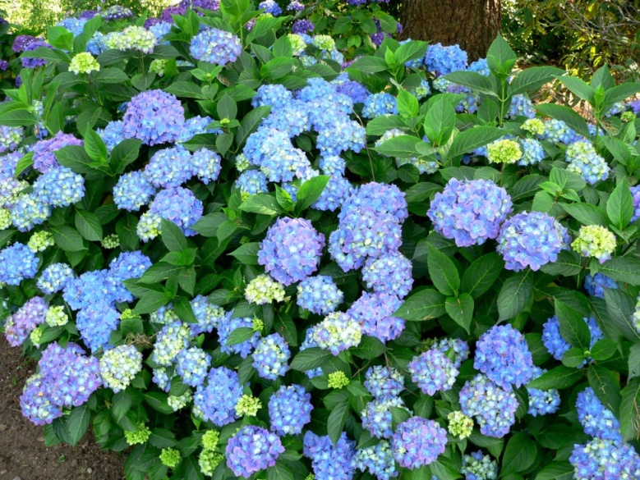
This method of propagation will work for Hydrangeas, Buddleja, Fuchsia, Hebes, bamboo and lavender. This is useful method because if the parent plant has any specific trait that you want then the cutting will also have this trait, also you won’t have to wait for a seed to germinate as the plant is already growing and partially developed.

Shane Sanders
Sexual Propagation
Lupin seeds
- Get some seeds from a reliable supplier so that you can ensure that the seeds don’t contain weeds, unwanted rubble, other types of seeds or any diseases or infections that will affect the growth of the plant or those around it.
- Prepare the soil by cultivating into a fine tilth so that the plant can easy grow through it to get its roots down, preferably have a loam based compost and make sure the soil is well drained, remove weeds from the soil so that the plant doesn’t have competition for nutrients in the ground and light to photosynthesise and if necessary add fertilizer to assist the growing plant. Preferably plant the seeds out of the wind. Lupins do not need nutrient rich soil and require a pH level of around 4.5 to 6.5.
- Soak the seeds in water and bleach for 24 hours because it will greatly lower the chances of a fungal infection that lupins are known for getting quite commonly. Also this will help to soften the seed coat making the plant germinate and grow faster.
- Sow the seeds at a rate of 30 grams per square meter when being used as decorative plants or being used as a cover crop or green manure to put nutrients back in the soil because this is the most you are able to get per square meter before the plants have to start competing for light and nutrients which will cause some plants to die and some to be smaller than they should be.
- Plant each seed at around 1cm deep because this is deep enough so that the seed is covered, protected and able to securely get its roots down while still being shallow enough so that the plant can easily break through the surface of the soil to help faster growth of the plant
- Fertilize the plants well to because fertilizers will help the plant grow. Water until soil is moist because water helps with the absorption of nutrients and is required for the plant to photosynthesise. Make sure the soil is well drained because lupins are used to growing in reasonably dry conditions and it also helps reduce the chances of getting fungal infections that lupins are prone to getting
Environmental conditions Biological conditions
Make sure that if you have old seeds that you soak them in bleach and water for 24 hours to remove fungal infections, but if you have newly dropped seeds you may want to still soak them to ensure that the seeds don’t grow fungus. It is a good idea to add pesticide and fungicide to the plant about once a month to stop fungal infections in the grown plant.
Plant the seeds during autumn so they can grow over the winter to flower in spring. The seeds like well drained soil so that you ensure the plant won’t get water logged and begin to rot. These particular seeds do not need a nutrient rich soil but they like to have an acidic soil to help them grow better, they also like to have a sheltered place out of the wind when they grow so that plant doesn’t get thrown around by the wind

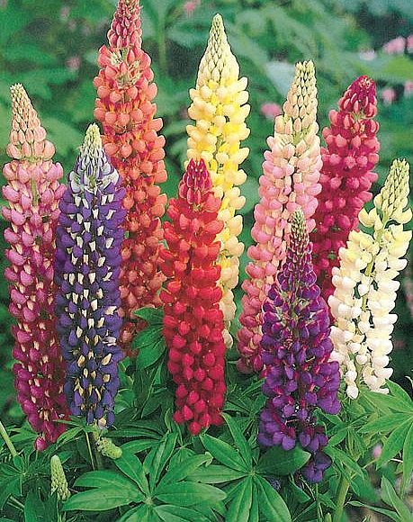

Lupins are poisonous to people and animals so it is a good idea to keep it away from animals and small children. If lupins are good for being used as green manure which are plant the put nutrients such as nitrogen back into the soil, if they are being used as a cover crop plant 6-8 weeks before you want to plant your official crop. This method of propagation works for most different variations of lupin, rosemary, lavender, Nandina flowers and Dianella flowers.

Shane Sanders

