Agricultural Waste
Agricultural waste is in waterways is mainly attributed to excess water and nutrients (fertilizers and effluent) from farm land entering water ways and leading to environmental degradation.It is difficult to detect waste miss-management as it is often non-point source contamination. Faecal contaminants are an issue for every farmer, the distribution of waste from the dairy shed and from the cows in the paddock is a constant pressure unlike fertilizers where application can be restricted.
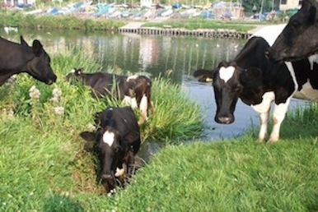
Cows trampling plants and riparian zones, and adding faecal matter to waterways, Source: i.thelocalpeople.co.uk

Why is this an issue
Faceal contamination reduces the quality of the water for drinking and recreational purposes. Increased levels of E. coli is directly associated with faecal contamination, leading to illness to those who come in contact with the water.
The increase of nutrients (particularly nitrogen and phosphorus) can also be linked to faecal contamination. Increase of these nutrients can induce eutrophication, the most common form being cyanobaterial blooms (blue-green algeal blooms). This initially causes an issue by out competing other photosynthetic organisms and releasing toxins toxic to vertebrate species. Secondly when the bloom runs out of resources the dead bloom rots reducing the oxygen available in the ecosystem leading to the death of fish.
The aesthetic qualities of the water ways can also reduced. The increase of the contaminants and plant life decrease the clarity of the water. And the toxic cyanobacteria reduces wild life and carcasses can be found in and around the water.

Economic Development
As one of the biggest industries for the New Zealand economy it is important to maintain and uphold environmentally sustainable practices. With the lucrative money the industry gets from its supply to around 151 countries (most importantly china) it is becoming more and more cost efficient (Ministry for primary, 2013). Along with the growing cow numbers, the numbers of herds have been decreasing but the herd sizes have been increasing. This has meant the number of cows per hectare has risen from 2.7 in 1981 to 2.76 in 2011 (dairyNZ, 2011). This has been greatly helped along by the introduction of irrigation. With this increasing pressure on the environment the risk and amount of pollution and damage to it is getting higher. This can seriously harm the clean green image New Zealand has so strongly invested in if proper environmental management procedures are not cared out correctly. Harm to this could greatly hinder other sectors like tourism.

Economic
Dairy farming is a very important industry to the New Zealand economy. It is an industry that has been growing steadily for the last few decades. The numbers of cows in New Zealand have increased from 2,060,898 in 1981 to 4,528,736 in 2011 (DairyNZ, 2011). The total amount eurned by New Zealand-based dairy firms is approximately NZ$18 billion (Coriolis, 2010). 95% of the milk produced in New Zealand is exported making the dairy sector responsible for around one third of the country’s exports (Ministry for Primary Industries, 2013). Dairy exports represented 27% of the total $41 billion earn in merchandise exported in 2009 (Coriolis, 2010).

