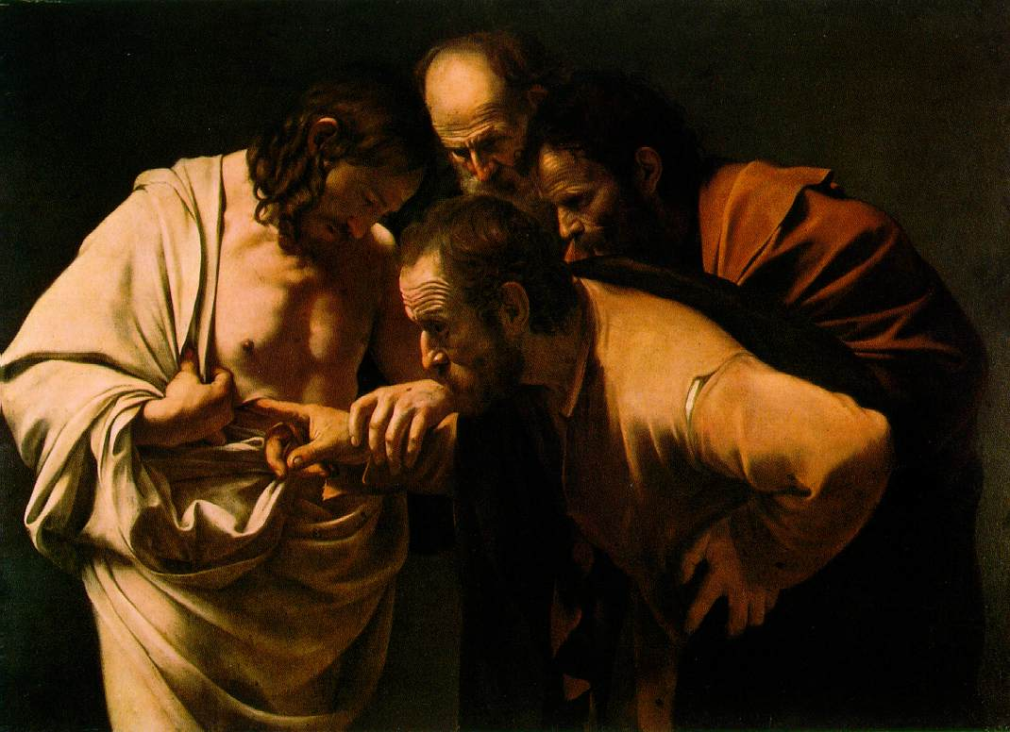
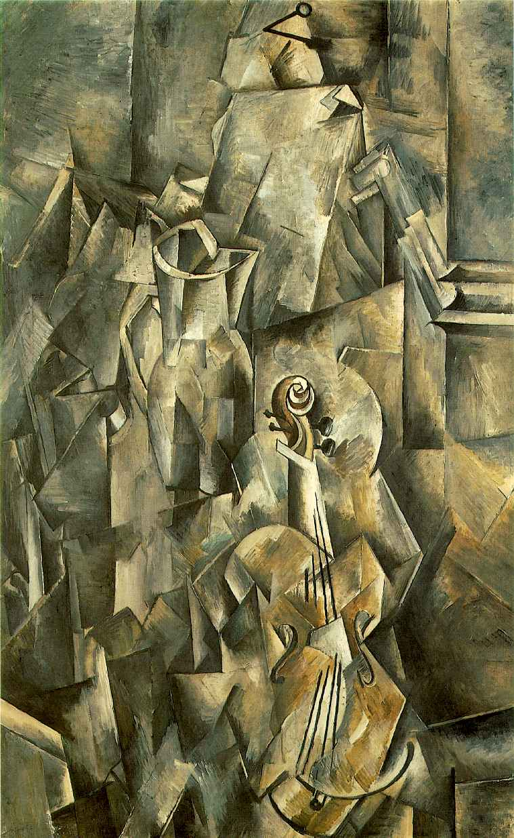
Cubism and Oil Painting
at the Liberal Arts Gallery of Dunedin
Georges Braque
Violin and Pitcher
Oil on Canvas
1907

Violin and Pitcher, painted in 1907 comes from the Analytical Cubism phase, where artist’s like Picasso, Braque and Juan Gris sought to fragment and break apart their subjects “as a surgeon dissects a cadaver”.

During this phase the artists utilized mostly oil on canvas as their media of choice. Oil paint has been used by artist predominately since the 1500’s and for centuries has been the media of choice for painters because of its slow drying qualities and ability to thin or thicken the consistency of the paint simply by adding more or less oil, such as linseed. The technology of Oil painting was a popular advancement from the Tempera medium, which was faster drying and usually involved an overlapping of gradual tonal shifts to obtain changes in light to dark, even more difficult was the laborious process used in fresco.
A slow drying time gives the artists the time to make changes and most importantly blend the colours and tones into one another, hiding the brushstrokes and giving a naturalistic impression of gradual tonal shifts of light. This ability to control light and how it is depicted gave artists like Caravaggio, Leonardo da Vinci and others since the time of the Renaissance the power to create in their works an illusion of reality, create realistic three-dimensional looking form on their flat canvas surfaces and descriptions of the optical world they chose to represent. Techniques such as chiaroscuro (creating strong contrasts between light and dark) became the means in which many artists in the centuries from 1500 to 1900 used to model the illusion of realistic forms and subject matter, one of the so-called ‘Academic techniques’, including allegorical narratives, the nude and smooth/slick surface texture.

They were also able to adjust the paints consistency or thickness, meaning the artist could more easily hide their brushstrokes by thinning the paint to a flat, even texture and thus also aiding in creating an illusion of reality and enhancing the idea that it was something more than just ground and powdered mineral pigments and linseed oil smeared upon a woven cotton material that was stretched across a wooden frame.
Picasso had used similar ‘traditional’ or ‘academic’ techniques during his Rose and Blue periods, blending tones to show an even range of light to dark, ‘thinned out’ oil paint and lees obvious brushstrokes so why suddenly did the Cubists want to reveal the ‘hand of the maker’?
The Incredulity of Saint Thomas
1601-02; Oil on canvas, 42 1/8 x 57 1/2 in; Neues Palais, Potsdam

The Cubists, such as Georges Braque, during this Analytical period, instead applied the oil paint thickly, unthinned- as if it were straight from tube, in small dabbing brushstrokes that are clearly defined and easily recognizable. Their mono-chromatic palette of browns, ochres, whites and blacks are applied in these ‘dabs’ side by side, or on top of each other, sometimes ‘scumbled’ into each other and blended directly on the surface, but always discernable as nothing more than paint, applied by a brush, quickly but thoughtfully. These strokes help to give a sense of direction, reinforcing the angles of the planes or fragments, giving the surface a shimmering quality, as light, which falls from multiple directions on each separate facet, ambiguously advances and receeds. The viewer of this surface knows this is no optical depiction of what the artists sees, we know this is no ‘illusion’ of a visual reality, but the concept, the idea of an artist. No disguising the mark of a maker, the Cubist broke from the Academic traditions of how oil was to be applied, much like the Impressionists before them had done with their thick, heavy brushstrokes and textured paintwork.
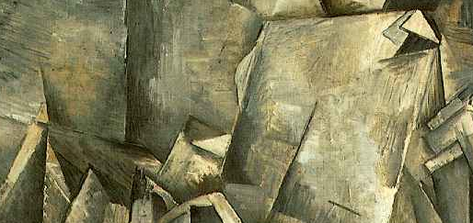

This is a painting. A truth in its own right. Not a copy or mimesis of a truth, the surface and the canvas, the buttery texture of oil paint becomes the vehicle for transporting an idea, a concept which the artist declares is truth in itself, no mere copy.
They are telling us… one perspective is not how we know the world, we know it from how we experience it, see it, remember it and interpret it… multiple perspectives, like the angles and facets that create the compositions. They uses ‘passages’ that link the simultaneous views together, thus creating a unified composition that ties together the entirety of the surface so no one element or subject becomes the focus. These lines, straight and black, dissect the facets, like cuts, creating a passage from one facet to the next, uniting them into a single unified surface. This surface buckles and protrudes and space is not deep, unlike the illusionism of traditional one point perspective (another radical rejection of traditional convention)
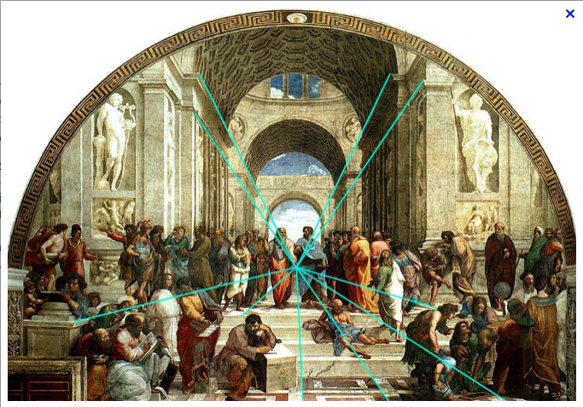
Raphael, 1509-1510, ‘The School of Athens’.
Fresco. Apostolic Palace, Vatican City.

Example of use of one-point perspective to create a window-like illusion of receeding depth on a flat surface.
which creates a ‘window’ for the viewer to look into, but instead comes forward to confront the viewer. This sense that some facets come out from the surface of the picture plane, whilst some recede to the canvas itself is given further enhancement by the artists treatment of tone and light. Shadows that fall from various directions and highlights that shimmer on the edges of the sharp, angular facets give a sense of overlapping. That these fragments or shards of a fractured surface have been stacked, overlapped and reassembled in various moments in time, as various light source aid the ambiguity but also the sense that this is a subject viewed not just from various viewpoints all assembled together at once but also from various moments in time. A meaning constructed from not just a perception of the pitcher and violin but also from a memory and experience the artist has of his subjects. He knows the violin from more than just his momentary visual experience of it, but from a life of having it about him, hence the ‘common’ objects portrayed, even the portraits where of people known well to the artists.
Adding to this sense of space protruding from the canvas rather than into it, is the Cubist use of Trompe L’Oeil (literally ‘trick the eye’).
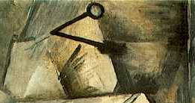
We see a nail protruding out from the work and casting a show on the surface below. Why among all the breaking down and reconstruction of realities and rejection of optical representation has Braque painted a whole nail jutting from the surface like it was driven in to hang the painting up? Picasso and Braque did not want to break away from totally from iillusionism, they never wanted their work to become completely abstract. The nails in their Analytical phase is a visual pun about the nature of representation. That a picture is not an illusionistic representation but rather an autonomous object and this is a pre-cursor to their inclusion of collaged elements in what would be their next phase, Synthetic Cubism.

