Assessment Task, one:

Pick a painting by Georges Braque from the Analytical Cubist phase.

You are going to make an ‘Exhibition catalogue’ that explains the media and processes of the work and how it impacts on the style and meaning intended by the artist.
To do this:
- List the title, date, dimensions and information on the medium (the WHAT?).

Next….You must comment on HOW the artist has painted it (the processes)…describe;
- Subject matter (what is in it?/what is it of?)
- How the subject has been depicted (abstracted/naturalistic)
- Composition
- Colour
- Texture
- Brushstrokes/paint application/technique
- Space/depth
- Light
- Line
- Form

Lastly how have these affected the meaning the artist intended the painting to have? (The WHY?)
- Why did the media (what he painted with) and how he did it (style) impact on the way his intentions or ideas are communicated (meaning)?

Include an image of the work, perhaps do a bit of fancy design stuff.
About 500 words.

“MY CUBIST WORK”

Subject Matter task:

1. Find and study at least 12x different works by Picasso and Braque and write a list of the different subject matter you can see.
Ie.
- Violin
- Candlestick
- Person

2. Would you say they were easily recognizable?
3. Are they naturalistically depicted?
4. Why have the artists chosen these types of subjects?

Composition task:

Analytical cubism has a very unique way of arranging the things in the artwork.

- Pick an artwork you liked most from the previous task… draw over the top of it/redraw it, drawing only the most important lines/objects in (teacher will demonstrate) on to you canvas board.
In words…how would describe the way the painting has been arranged? Ie.
- Is it balanced or is there tension?
- Is any one subject dominating the scene?
- What angle, distance or viewpoint are the subjects viewed from?
- Has the artist used any devices/tricks (perspective/passage etc) to construct or arrange the image?

Colour:

1.What colours has the artist used in the image you have chosen? (list them)
2. Describe the ‘palette’ or range of colour choices using descriptive, detailed terminology relevant to colour theory. Creative ADJECTIVES!!!!

Texture/brushstrokes/techniques:

- Looking at the artwork you have chosen, go back to your canvas board, select the colours you have identified and paint into the composition you have copied with an emphasis on replicating the same brushstrokes/texture and technique you think the artist has used.
- Describe what you have done and the way you applied the paint… did you blend it (like da Vinci)? What kind of motion did you use with the brush? Did you mix the colours? If so on the palette or on the board? Did you vary the direction of the brushstrokes? Was it slow and careful, delicate, meticulous, painstaking and accurate OR fast, wild, gestural, expressive, free?

Space/Depth:

Now looking at your painting…
- Does it give the illusion that it recedes or goes backwards in space? Perhaps it even comes forwards, towards you?
- How is this achieved?

Line/Form/tone/light:

1. Are there evident lines or has it all been blended in, like a da Vinci?
If so… What sort of line has been used? (geometric or organic) Describe them.
2. Tone is the gradual change from light to dark shades used to help describe the form or mass of a subject…does your image do this?
3. Light… what sort of light is there…natural, clear like its outside or dark? What type of mood does this convey?
Is there a single light source or multiple? Why?

The BIG question…. Why has the artist done all these things? What is the point for it all? They must have had a reason right? After all, Picasso dramatically changed his painting style from like this…
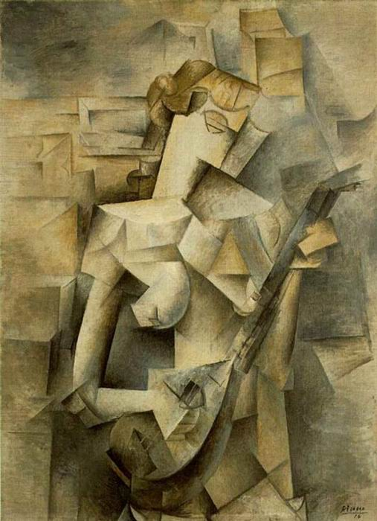
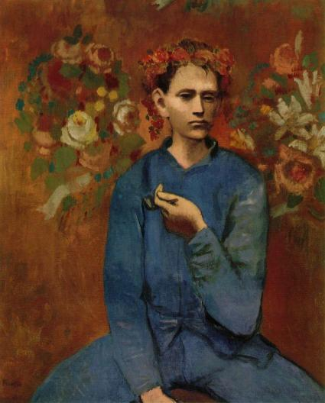
Picasso. 1905. “Boy with a Pipe”

to this…
for a reason, right?

