Investigation Planning and Result Sheets
Student name:
- Investigation Purpose (your aim, testable question, prediction or hypothesis)
To find what type of food would be the most effective for the farmer to grow chicks at the fastest rate whilst still being cost effective.
Collect and Record Data
Independent Variable
- Fair Test
Which variable will be changed? (e.g. the independent variable?)
The type of feed will be changed. The types of feed will be pellets, crumble and mash. The foods are different sizes, which will affect digestibility as the smaller the food the less time, and energy the chick will have to put into getting the nutrients out. Also they have different nutrient levels as they are made for different ages which have different nutrient requirements.

How will the independent variable be changed?
By having 3 groups of 5 chicks and feeding each group a different type of food.

Give a suitable range of values for this variable
 | Pellets | Starter Layer mash | Starter Crumble
Protein | 16% | 16% | 20%
Fat | 1.5% | 1.4% | 4%
Fibre | 3.5% | 3% | 3.5%
Salt | 0.2% | 0.2% | 0.3%
Cost | $14.40 | $14.30 | $16.20
Size | 10mm | 1mm | 4mm
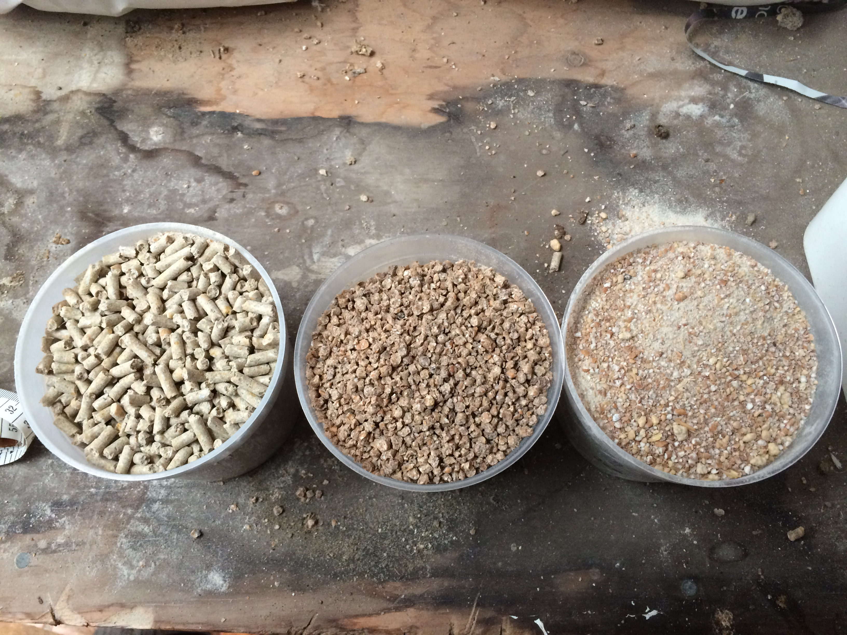
The pellets and mash both have the same ingredients they are:
Barley, canola, copra, grass meal, linseed, lysine, maize, methionine, minerals (including dicalcium, phosphate and limestone), oats, peas, salt, sodium bicarbonate, soybean meal, soya oil, threonine, vitamins, wheat, wheat by products and yolk colourant.

The starter crumble has the same except it has trypotophan and doesn’t have yolk colourant and sodium bicarbonate.

Dependent variable
- Fair Test
Which variable will have to be measured or observed in order to get some data or information from the investigation? (the dependent variable)
The dependent variable of our investigation is the weight of the chicks.

How will the dependent variable be measured or observed?

We measured the chicks by taring a bowl on the scales then put a chick in the bowl and writing down the weight. We then averaged the 5 weights (4 for group c after one of the chicks died on day 18 of the investigation) to get the average weight for each group.

How many samples will you need to take to get reliable data?
We will take 5 samples as there is 5 chicks for each type of food. The investigation will go for 20 days

Other variables that need to be controlled to make your results more accurate
Variable | How will this variable be controlled or measured?
Daylight | Chickens are photoperiod sensitive and if one group got longer light periods then they would eat for longer. To offset this we covered the widows with sacks so the only light they got was the light from the heat lamps. This means all 3 groups got the same amount of light.
Amount of food | We gave the chicks 450 g of food each day. We did this by weighing the food on the scales after taring off the bowl. Then deducting the weight of the food that is left off the starting weight. Eg. 450-350=100g
Temperature | Chicks have a optimum temperature that they grow best at. We used the heat lamps to keep them within 3 or 4 degrees from this.
Stress | If the chicks are stressed they wont eat as much so wont put on much weight. To reduce the stress we locked the shed to keep other classes out, also this stoped them interfering with other things like food. We also kept noise to a minimum when we were around them and only we were allowed to handle them after Mr Clark showed us how to properly.
Hygiene | We kept hygiene up as to keep the heath of the chickens up. Everyday we cleaned out the newspaper and faeces from the bottom of the brooder and refreshed the paper. We refilled and cleaned the water containers each day. During the first 10 days, the chicks had faeces stuck around their vent so we had to get it off by wetting and crushing it. If we hadn’t done this the chick wouldn’t have been able to poo.
Breed | The breed has a huge effect on the growth rate of the chickens. We used brown shaver hens for our experiment which are meat breeds and would grow a lot faster than egg layers as they have better genetics. Their genetics are for selected for best conversion of nutrients and protein into muscle so they are ready to sent to the market as soon as possible.
Time of day the chicks are weighed | The time of day the chicks are weighed is important because if we weigh one group at a different time to another, the chicks will have time to eat more food and put on more weight.
How will you make sure that your results are reliable?
We will make sure our results are reliable by making sure these variables don’t change as this will cause the test to become unfair. If something happens to one group, it will have to happen to all the groups. The chicks are also coming from the same hatchery and are born within a few hours of each other so they all have exactly the same genetics, and are the same age.

Notes from your trials

On day 2-8 the group eating pellets (group 3) weren’t looking very good so we gave them some crumble to make sure they wouldn’t die.

Throughout the investigation group, c had quite runny poo and the water container was emptier than the other 2 groups because they were drinking more water to make up for the lack of food they were getting.

Group B are a lot more energetic than the other 2 groups. This was because they were getting more energy though fats and were able to eat more food so had more energy to burn.

Method
Use the information on your planning sheets to write a detailed step-by-step method.
Step 1 – Research day old chicks to find out what temperature they should be kept at, how much water and food they require, what target weights were and other relevant information
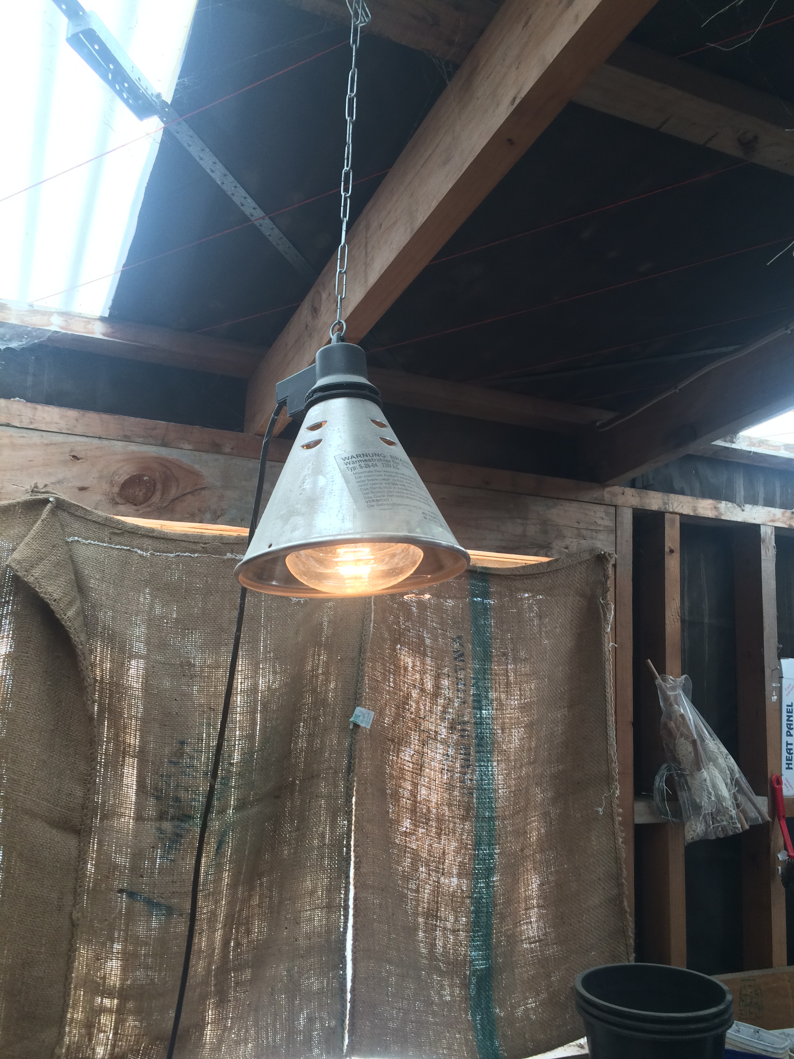
Step 2 – Set up the brooders. We used 40l tubs for the enclosures, each of which held 5 chicks. We put shredded paper in the bottom to soak up faeces. We cleaned all the water and food containers and filled them so Mr Clark didn’t have do anything when the chicks arrived and hung the heat lamps above each enclosure. We adjusted the height of the heat lamps to be around 30 degrees Celsius. We found some netting to put over the brooders to keep the chicks in and heat and air can still get though easily.
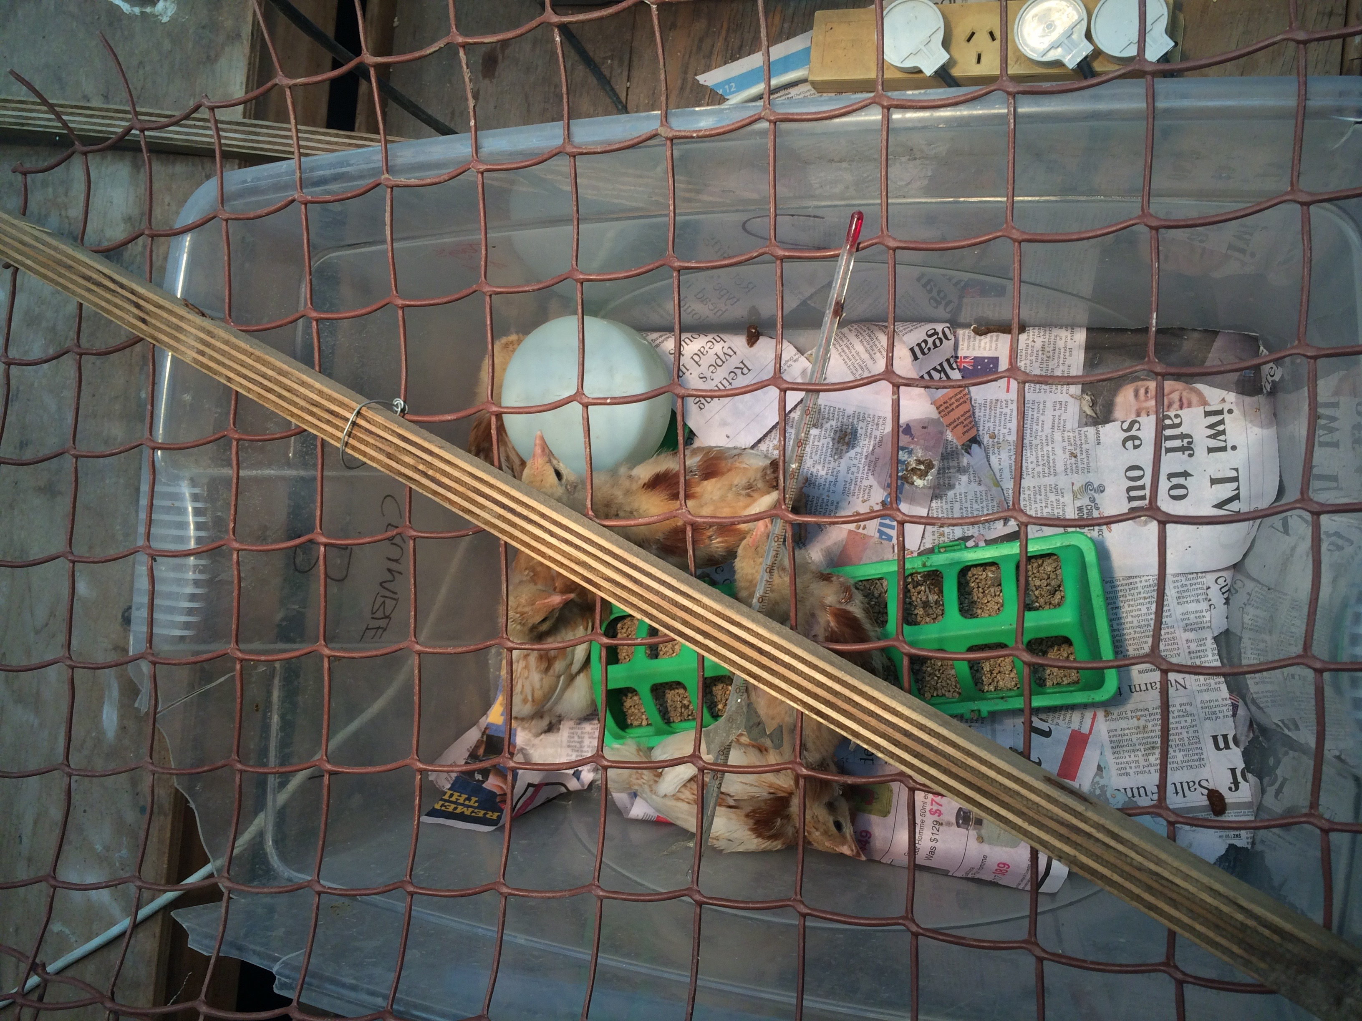
Step 3 - The day we got the chicks was a Friday and we want to start the investigation on a Monday so over the weekend to keep it simple we fed all the chicks on starter crumble.
Step 4 – on the day we started the investigation we filled the water containers right up so the chicks could get all the water they needed and weighed the amount of food for each group so we could measure how much they ate. Each day we gave them 450 g of that group’s food, which was more than enough for them to eat as much as they wanted without running out. While doing this we cleaned the food and water containers to keep hygiene up.
Step 5 – Each day of the investigation, we weighed the chicks by putting them by taring a bowl on the scales then putting the chicks in the bowl and taking the weight. We recorded each weight and then averaged the weights across the group and recorded it. Whilst we were handling the chicks, we would check them over to make sure their vent was clear and their general heath was all right. We also cleaned out the brooders and refreshed the newspaper on the bottom. We also had to take the temperature and adjust the heat lamps to the optimal temperature. The further into the investigation we got the lower we made the temperature as we were trying to get the chicks to adjust to the outside temperature so it wasn’t such a shock when they left the brooders.
Step 6 - We repeated this each day for 20 days until the investigation was over.
Step 7 – Once the investigation is over write up changes made to method record information on excel and process the data into graph so in can be quickly and easily referenced and compared. Also write up the interpretation, conclusion and evaluate the method and data.
Changes made to the method
On day 19 the group that was supposed to do the chicks didn’t weigh them or the food which meant we didn’t have any data for that day. That meant we needed to carry on the investigation an extra day to get 20 days of data. This didn’t really effect the investigation as the trend was already showing in the data.

In the days between 2 - 8, we had to feed group c some crumble to keep them alive, as the investigation wouldn’t be very conclusive if they died.

On day 18 one of group C died so we had to divide their weights by 4 to get the average.

We filled the water containers right up so the chicks could get all the water they needed and weighed the amount of food for each group so we could measure how much they ate. Each day we gave them 450 g of that group’s food, which was more than enough for them to eat as much as they wanted without running out.

Findings Report Sheet
Recorded data

weight |  |  |  |  | food eaten
days | group a | group b | group c |  | days | group a | group b | group c
1 | 57.14 | 59.5 | 53.5 |  | 1 | 63.2 | 76.2 | 63.3
2 | 61.63 | 66.2 | 58.1 |  | 2 | 70.9 | 88.7 | 62.5
1 week 3 | 67.3 | 71.7 | 61.9 |  | 3 | 40.5 | 75.2 | 87.3
4 | 85.59 | 83.5 | 70.4 |  | 4 | 101.5 | 125 | 89.6
5 | 81.94 | 90.8 | 74 |  | 5 | 79.3 | 103 | 75.3
6 | 85.17 | 96.2 | 77.7 |  | 6 | 58.2 | 68.1 | 7.7
7 | 98.7 | 107.06 | 84 |  | 7 | 98.6 | 124.7 | 82.4
8 | 99.21 | 116.46 | 89.1 |  | 8 | 115.7 | 125.4 | 82.8
9 | 106.94 | 124.18 | 92.6 |  | 9 | 104.6 | 133.7 | 80.7
2 weeks. 10 | 112.2 | 132.3 | 102.1 |  | 10 | 100.7 | 119.3 | 68.2
11 | 118.3 | 143 | 104.1 |  | 11 | 132.8 | 139.3 | 73.5
12 | 127.2 | 155.7 | 106.1 |  | 12 | 139.2 | 148.7 | 80.7
13 | 135 | 168.2 | 118.9 |  | 13 | 137.4 | 161.6 | 95.1
14 | 143.4 | 169 | 122.4 |  | 14 | 138.4 | 137.2 | 87
15 | 150.9 | 195.3 | 132.4 |  | 15 | 185.3 | 211.9 | 90
16 | 163.26 | 209.6 | 133.6 |  | 16 | 224.1 | 224.8 | 71.8
3 weeks. 17 | 170.6 | 219 | 137.9 |  | 17 | 162.2 | 140.8 | 68
18 | 176.3 | 232 | 147 |  | 18 | 236.2 | 250 | 90.3
19 | 189.2 | 274 | 168.7 |  | 19 | 207.4 | 234.3 | 103.2
20 | 206.4 | 296 | 184.7 |  | 20 | 249.6 | 232.4 | 121.2

Processed data
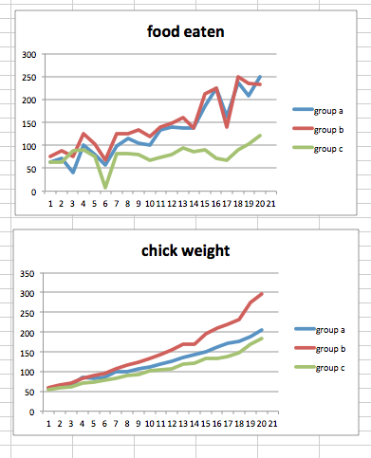
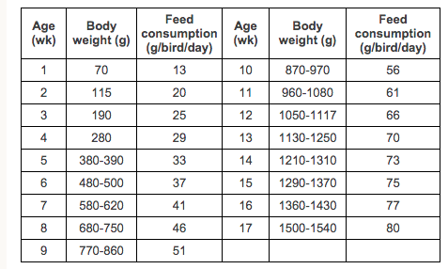
Interpretation of data –
Of the 3 groups group B grew the fastest. They also consistently ate the most and had the food that was the highest in protein and fat. As you can see in the table below and my recorded and processed data group B always made target weights and feed consumption per bird per day whereas group c was well below it and group A were just behind. This was because the chick’s gizzard wasn’t fully developed so it couldn’t take the full size pellets very well and the mash and pellets had less nutrients than the crumble. In the food eaten graph you can see the food consumption dips on day 6. This is because on day 5 the chicks were done at 6.30 pm and on day 6 they were done at 11.00 am. That is the reason that the graph is all over the place because each day weighed the chicks and food at different times each day.
Conclusion –
We determined the most effective feed for growing chicks is by far the starter crumble. This is because it has the most protein (by 4%) and fats (by 2.5%) and is digestible for young chicks. This meant the could build muscle faster as they have more energy though the fat which means they can eat more and more effectively use the protein to build muscle mass. The crumble was what group B had was a lot more digestible than the pellets that group C had as they were crushed up more. This meant that group B didn’t have to put as much energy into digesting their food as group C and it also meant that they could eat more than group C as the crumble doesn’t take as long to break up.
Chickens are mono gastric, which means they have a single stage stomach. Their digestive system is different to ours because the digestive enzymes are added before the food is chewed up. Then the food moves to the gizzard where muscles grind the food aided by grit and stones (which the chicken swallows but the chicks didn’t have as there wasn’t any in the brooder). This is called physical digestion. This process also mix’s the enzymes that were added earlier with the food that now has a greater surface area for the enzymes to work on. Because the pellets are bigger than the other 2 food types, they take longer to break up this way and then they yield less return when the small intestines absorb the nutrients. This is the other part of the reason why group C didn’t meet target weights and group B did.
Group B did Better than group A because even though the mash was smaller and easier to digest it had less protein and nutrients in it to aid in the growth of the chicken. This meant that Group A had to eat more mash to get the same amount of nutrition but there is a limit on how much they can eat as they cant digest a unlimited amount of food. This meant that Group B pulled away from group A in weight even though they were eating similar amounts of food.
This means if you were a farmer wanting to start a brooding business you would choose the starter crumble because it has the highest nutrient levels needed for the fast growth of young chicks and it is also highly digestible. It also is the cheapest out of the 3 foods to buy so you get a higher return when you sell the adult chickens.
Evaluation of the method and data
In our investigation, we followed the method quite well and any changes to it are stated in the “changes to the method” box. The data isn’t as reliable as I would have liked because of the chicks were weighed at different times each day but still showed us what we needed to know which was the most efficient feed to cost effectively grow chicks on.
If I were to change anything for next time, I would insure that the chickens are weighed and the feeds measured and the same time each day e.g. 11.00 am. This would make the data more accurate and reliable as they have the same amount of time to grow and eat.
I would also use a temperature controlled room so we could monitor the temperatures better rather than the heat lamps possibly being set lower down for a cold day then having a warmer day where the heat lamps should be higher to keep the temperature the same.
We should have started each group on the feed they were assigned to for the investigation as the 2 groups that changed (groups A and C) had to adjust to their new feeds whereas the group that was on crumble (group B) carried on as normal. This may have reflected in our results because group B came out on top.
I would have made the investigation longer as once group c got big enough to effectively digest the pellets they may have had a dramatic increase in weight.

