Grass and Clover Seed Germination and Growth

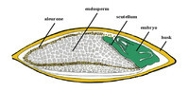
During seed germination the seed has to absorb water, which swells the seed to break the outer husk and trigger the embryo into producing the hormone gibberellin (GA). This growth regulating hormone activates the aleurone layer which, in turn, secretes amylase for the hydrolysis of starch and proteins into the endosperm. The breakdown of the starchy endosperm then supplies sugars, which are consumed by the emerging radicle extension from the seed and feed early roots and first leaf development.
It is at this point, when the seedling has exhausted the food reserves within the seed, that germination ends and establishment starts. This is a critical phase in the life of the grass plant when they are most vulnerable to mechanical damage, water stress and disease. The seed has now done its job and no longer has any influence on further development. It is then external environmental conditions which determine how successful establishment is.

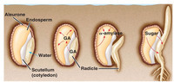
The first step for the seed in its germination process is the absorption of water. In early spring, there will be plenty of water/moisture available for the seed, but later on, especially if the seed bed preparation is done without regard to the capillary water, water shortage can be fatal.
Germination is strongly related to soil temperature. The higher the soil temperature is in spring the quicker germination will be. Seeds sown in conditions below the basic (minimum) temperature for germination (this value varies from species to species), will not start their germination processes.
If a seed needs to wait for suitable ground temperatures, there is an increased risk of reduced seed viability through either rotting or the food source within the seed becoming depleted as the seed falls in and out of the germination process.

Soil temperature
The temperature of a soil is important as it affects how fast plants can grow. Soil temperature also affects how quickly plants take up water and nutrients. Clay soils are cold, wet soils. Germination and seedling growth is usually slow.
Because sandy soils don't contain much water but lots of air, they warm up quickly. They are useful for growing early crops.
Soil temperature affects the speed of chemical reactions. Warm temperatures speed up reactions and colder ones slow them down. Soil temperature affects the breakdown of parent material and how fast micro-organisms work. Both are important in adding and returning nutrients to the soil. Soil temperature is influenced by the climate of the area and the season of the year.

Aspect
The slope of the land and the direction that it faces directly affects the temperature of a soil. Sun will fall on north-facing land during the day in both summer and winter.
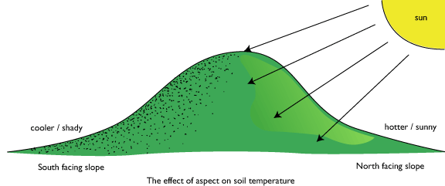
During the winter south-facing slopes will get less sun during the day. The soil on these slopes cools down quickly in the autumn and warms up slowly in the spring. In the middle of summer these areas will have better growth because the soil is not as hot and dry as the soil on a north-facing slope.

