Demonstrate Understanding of a Significant Development in Media

When discussing Hitler and Nazi Germany it’s easy to just say “He was an evil, terrible man” but the truth is Hitler was one of the most gifted commanders and leaders ever to live. If Hitler had been successful, which he was so close to doing, then we would all be talking about how amazing of a leader he was during the war. I’m not saying that Hitler wasn’t a horrible person, he was. I am saying that just because he was a delusional psychopath doesn’t mean we should dismiss all the traits that got him into his position of power. Hitler and the Nazi’s used many tactics to sway and hypnotise the general population of Germany into his way of thinking. From film, to radio, to posters on the street, Joseph Goebbels (The head of Nazi propaganda) and Hitler saw the public it as an issue of utmost importance and kept it as a high priority throughout the war. All the different approaches added to the propaganda machine but in my opinion the most important was Hitlers speaking ability and how these powerful speeches he delivered inspired Germany.

When leaders speak now it very rarely holds the same weight and strength that it did when Hitler spoke. Some might say that this is because it was during war time. I believe this cannot be true as when Hitler started out there was no war and yet his speeches were as impactful as ever. So whats changed? Was Hitler just a freak of nature? A one off, that no one can replicate? I believe the reason for the effectiveness was more than purely Hitlers talent but also because of the way the media was delivered and received.

What development occurred

The art of the speaking to large audiences is still a key element of any countries leadership ability. However, how speeches are delivered and the way they are received has changed greatly. The best way to show the development of this form of media is too compare some of Hitlers key speeches with that of the prevalent modern day leaders: Barrack Obama. These two are at opposite ends of the political spectrum as Obama is a peaceful, clam and controlled leader, whereas Hitler was a radical, war mongering, hateful leader.

Context - The first and perhaps the most important development in the media of speech making is the context it occurred in. Obviously, World War II was one of the most dramatic and monumental times in human history. Firstly when Hitler in the beginning and throughout his political career he was speaking to a german people living in intense poverty and oppression. This meant that the message he delivered was one of intimidation and scapegoating. Hitler knew that the german people were unhappy with the way they were living, he also knew that the general german population disliked Jewish people. It was for this reason that Hitlers message in the speech were aggressive and radical. When we compare this to Obama it is easy for us to understand how context plays a huge part in the kind of message leaders try to get across. Modern day america may have its problems economically but it is far from the turmoil the german people were facing at the beginning of world war two. If Obama was to come out and say “Let’s tear down the current government system and go from a democracy to a dictatorship” Which is in a very simplistic sense what Hitler did. Obama would be immediately kicked out of the race and probably never be in government again. It’s hard to make drastic changes to a country or government unless times are really tough. The development here is that because of a more consistent and powerful government in place, speeches couldn’t be as drastic and controversial. Because of the state of the people in Germany it enabled Hitler to use intimidation techniques to effectively force the people onto his side. Where Obama uses promises of peace and prosperity Hitler ensured war and domination. When people saw the Masses at the Nuremberg Rally and saw the powerful S.S soldiers on the street abusing the Jews they would have been intimidated, thinking that if they voted against the Nazi’s they may be persecuted or even killed.

Nowadays we live in a world of immediate knowledge, you can google pretty much anything you could ever want or need to know. This means that when in the past leaders such as Hitler could et away with minor slip ups and telling the public blatant lies and having them believe them. Now in the days of the internet Obama is constantly scrutinised for the tiniest little discrepancies. This plays a huge part in how speeches are put together and presented now. When Hitler was building up his party and political campaign he spoke on the genetic prowess of the german people and on how the Jewish people were weak and covetous and said all sorts of lies about how genetics worked. He got away with it because of the ignorance of the german people, they knew nothing about how genetics worked and had no means of finding out if anything the Germans were saying about the Jews the Americans or the English were true or even if the Nazi’s were as powerful as they said they were. These days if Obama tried to say half the things Hitler did he would immediately be shut down by millions of people disputing his claims. The way technology had advanced over the last 50 years has forced development in speech making as far as the content is concerned. Now it is a lot more safe, less radical and overall more truthful and reliable.

Appearance - The appearance of campaign events at which leads speak has also undergone changes and development. Hitler was one of the first leaders in history to use modern day advertising in his campaigns. We see this in the detail he went into as far as the Nazi uniform and Symbols are concerned. Hitler saw the value in looking powerful so that people saw you as powerful and then because of the perception they eventually became powerful. We see this in all modern politics, Hitler was the first to use propaganda posters to strengthen his cause and if e compare them to the posters Obama used in his first campaign it’s obvious the impact the Nazi’s had.
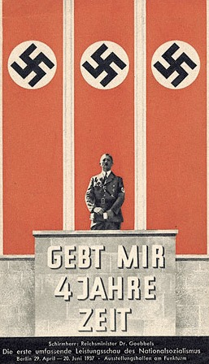

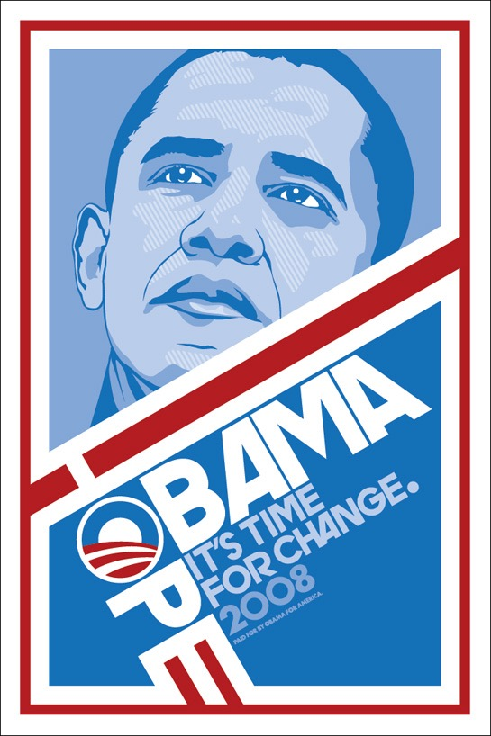
The development here is that the symbols have changed and the message portrayed by the posters is different the blue colours and proud looking face of Obama is a comforting hopeful poster whereas the Nazi poster imposes fear onto the viewer and gets across a vastly different idea.

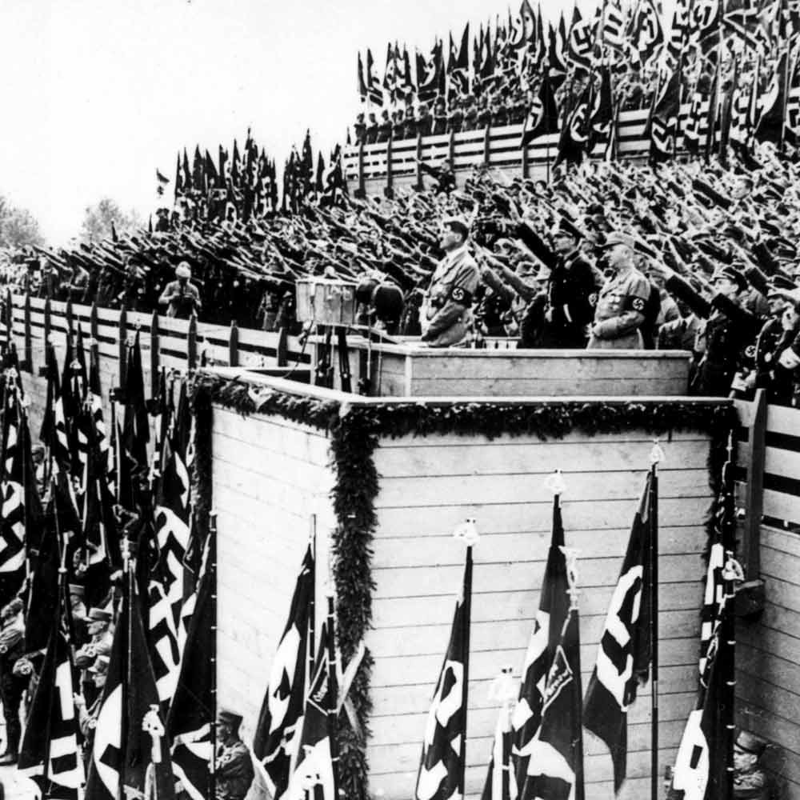
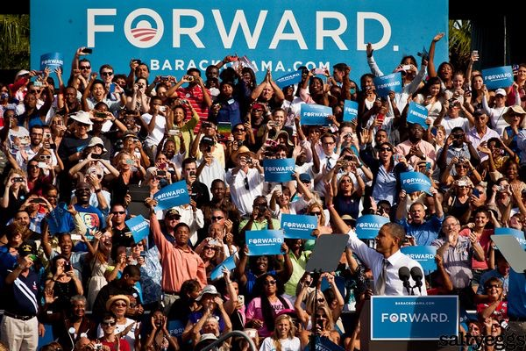
The rallies of these two leaders also share a lot in common. Although Hitler was far from the first to gather all his army and supporters in one place to show his power and dominance he did take it very seriously and saw it as a good way to show everyone that if they wanted to oppose Nazi Germany it would not be easy. Obama also has rallies however they serve a different purpose. When Hitler gathered his men and gave a rousing speech about restoring Germany to it’s former greatness and ridding her of the covetous Jew, he did so in a dominating way, he addressed the people with almost reckless honesty because he had absolute power as dictator. When Obama addressed his people he merely said what has been said many times before because these days in america no one wants a radical leader like Hitler and if he spoke as he did he would not be elected. In this we see how speech making has developed.

