Internal Assessment Resource

Achievement Standard Art History 91488: Examine the relationship(s) between a theory and art works
Resource reference: Art History 3.7B
Resource title: Modernist theory… “A Modernist Manifesto”
Credits: 4

Student instructions

Achievement | Achievement with Merit | Achievement with Excellence
Examine the relationship(s) between a theory and art works. | Examine, in depth, the relationship(s) between a theory and art works. | Examine, perceptively, the relationship(s) between a theory and art works.

Examine involves explaining the key principles of the theory and discussing the relationship(s) between the theory and art works, using supporting evidence from the art works.

Examine, in depth, involves analysing the relationship(s) between the key principles of the theory and art works, using supporting evidence from the art works and other sources.

Examine, perceptively, involves evaluating the relationship(s) between the key principles of the theory and art works, integrating supporting evidence from the art works and other sources.

Interview with F T Marinetti, Author of the Futurist Manifesto.

- For this assessment you will place yourself in the shoes of F T Marinetti, the founder of Futurism and the writer of “the Futurist Manifesto” and his Theory of what it is to be a Futurist. You will answer a series of questions, as if you were Marinetti being interviewed for a newspaper or article.

- You will have to familiarise yourself with and reference the “Founding Manifesto of the Futurists” and “The Manifesto of the Futurist painters” theories on what constitutes Futurist art.
You will also need to make links to other relevant Theories of the time such ie. Scientific theories, philosophical Theories or Political theories ie. Fascism.

- You have to make connections between the Theories and the Futurist artworks. This means describing aspects of the works that provide evidence of the Theories and their influences.

Be perceptive in your answers, this means integrating information from the artworks into your answers and evaluating it.
Use quotes and the Guggenheim exhibition catalogue. Research aspects of the Scientific, Political and Philosophical context to support some of your answers.

You will be assessed on the perceptiveness of your evaluation of the relationship(s) between the theory and the art works and your integration of supporting evidence.
You will not be assessed on the presentation of your article.
This is an individual activity. It will take place over four weeks of in-class and out-of-class time.

DUE DATE 4th September.

The Interview: Work your way through these questions/tasks as if it is an interview and you are F T Marinetti being interviewed by ie. Rolling Stone Magazine.

Welcome Fillipo Tomasco Marinetti… Please, can you tell us a little about yourself? (write a brief bio).

1. So Fillipo, in 1909 you wrote the Futurist Manifesto, the first of a series of Manifestoes, outlining what you proposed a ‘Futurist’ should be. What is a ‘Manifesto’ and what inspired you to produce such a document?

2. Can you please summarise for us the Manifesto and some of your ideas/theories on what a Futurist artist must abide by?

3. 1909, Italy… what was happening at this time Politically that may have influenced the creation of your Theory as it has been stated that you may be a Fascist?
What does that mean and is it true? (Can you please support your answer with evidence from the Manifesto or the artworks?)

4. So how does the colour, the brushstrokes, the subject matter and composition of the great Futurist masterpiece and icon of Futurist artwork “The city Rises” by Umberto Boccioni illustrate your Theory on what a Futurist should be?

5. I also really enjoy Boccioni’s “Unique Forms of Continuity in Space”, can you please tell us about how this work describes and portrays some of the Scientific Theories of the Modernist age?

6. So speed and dynamism is clearly stated as a major part of the Manifesto. What contexts were the inspiration for such a theme?

7. Can you please describe and discuss another work that you think captures this theory of the importance of Dynamism and how it does this?

8. You make claims to being ‘Anti-tradition’ and pro anarchy and war. What did you say in the Manifesto about these things and can you please discuss how that may be evident in a Futurist artwork?

9. Boccioni, Balla, Carra, and others wrote the “Manifesto of the Futurist painters”. What were they saying that can be illustrated by some of their painting?

10. Are their any other Theories of the Modernist era that can be illustrated by Futurist artworks?

11. So can you please explain the historical significance of the Manifesto and Futurism? What was its legacy? How did it influence other artists or other movements?
What happened to Futurism?

Umberto Boccioni “The city rises”. 1910
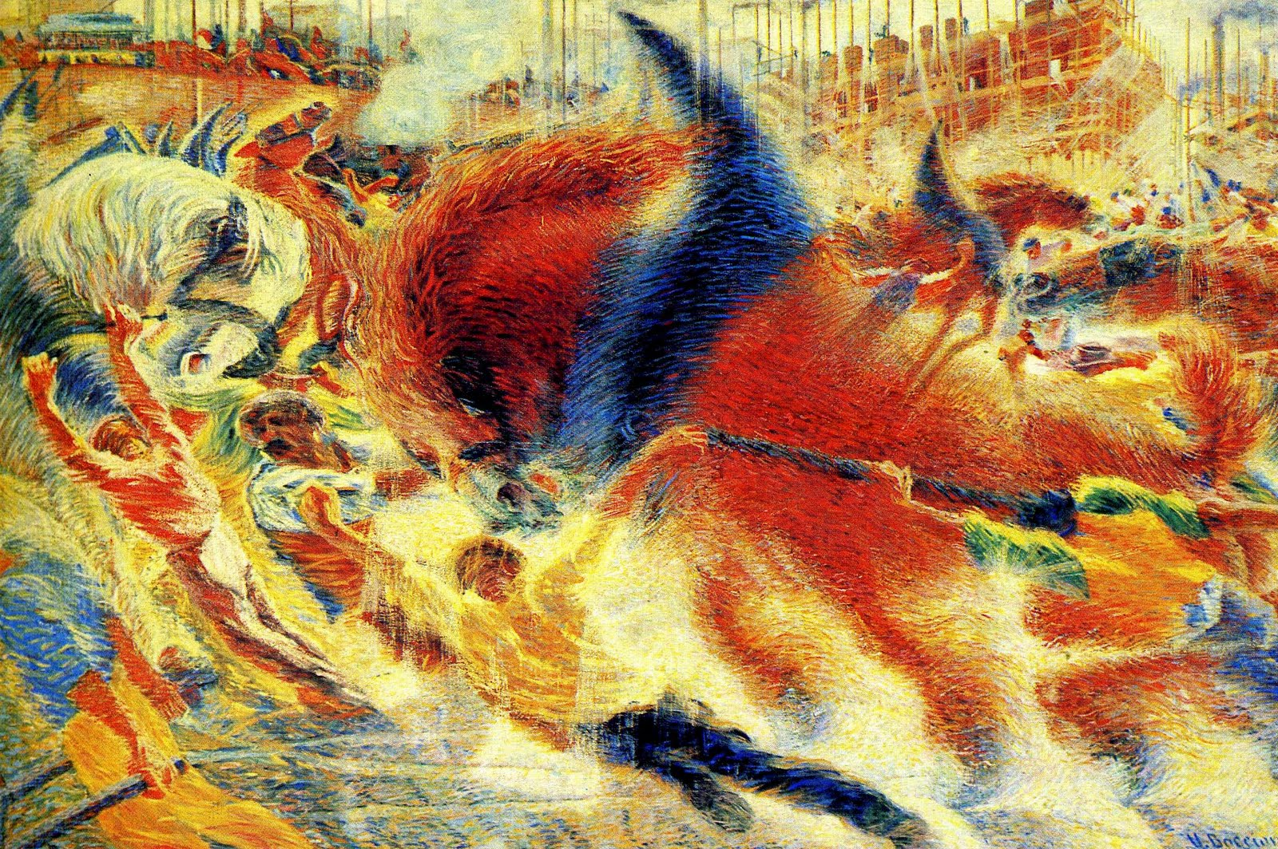

Giacomo Balla. “Lines of Movement and dynamic succession” 1914.
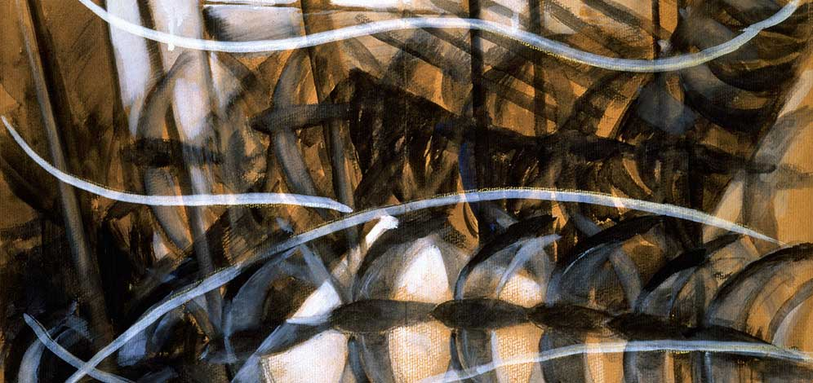
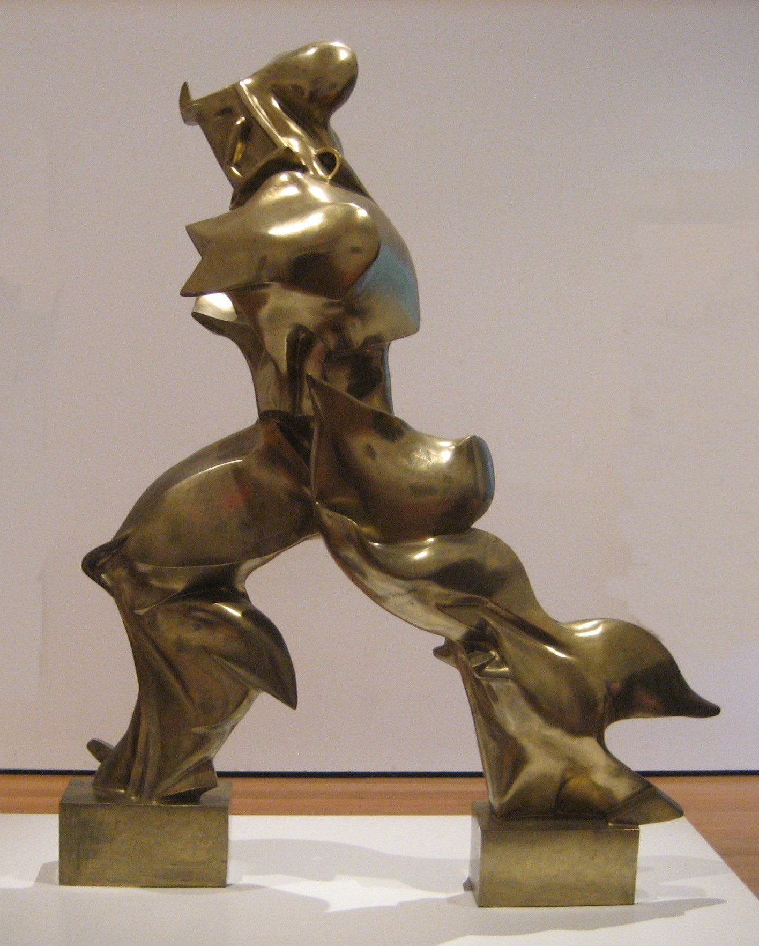
Umberto Boccioni “Unique forms of continuity in space”. 1913.
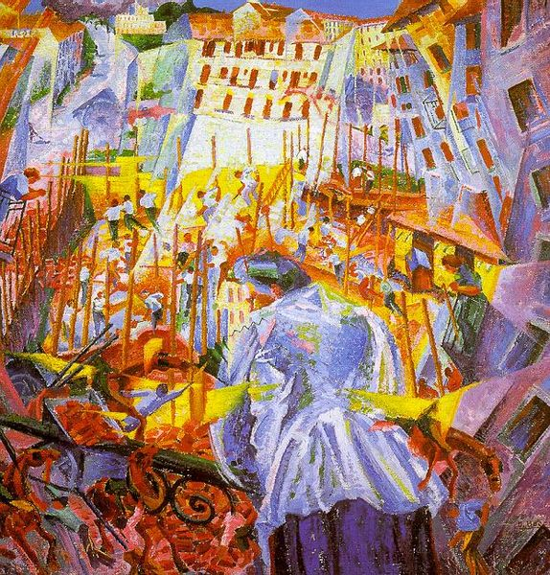
Unberto Boccioni. “The street enters the house”. 1911.

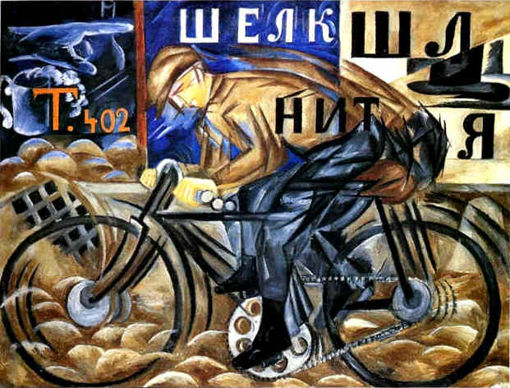
Natalia Goncharova. “The Cyclist”. 1913
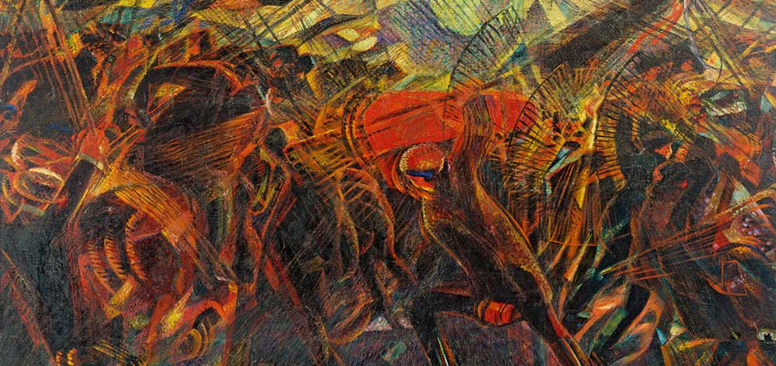

Carlo Carra “The funeral of the anarchist, Galli”. 1910,11.

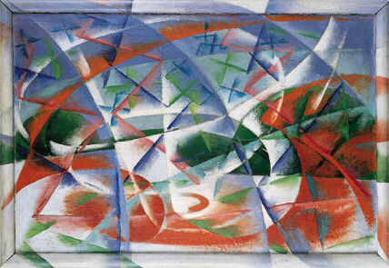
Giacomo Balla. “Abstract Speed and Sound”. 1913,1914.

