LEVEL 2, Agriculture : 2014
Content
2.1
Carry out an extended practical agricultural or horticultural investigation.
4 Credit INTERNAL
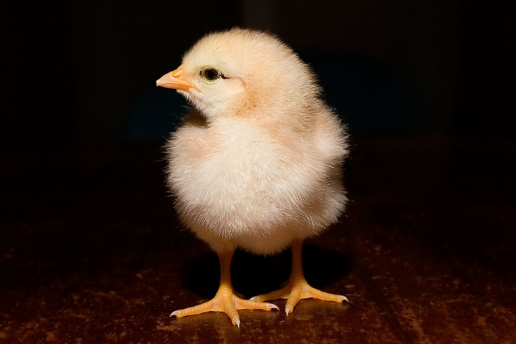

2.5
Demonstrate understanding of livestock reproductive technologies.
4 credits INTERNAL
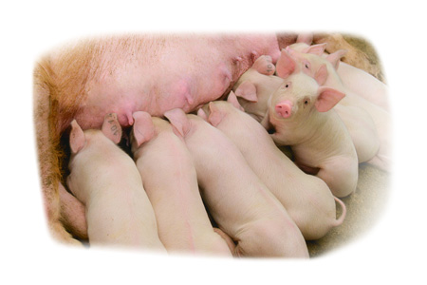

2.6
Demonstrate understanding of management practices influencing
livestock growth/development.
4 Credits EXTERNAL

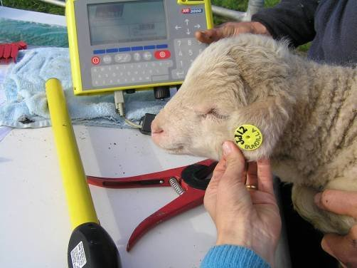
Context details
Candidates will be expected to have an understanding of:
• pigs
• cattle
• sheep.

2.9
Demonstrate understanding of land use for primary production in New
Zealand.
4 Credits EXTERNAL
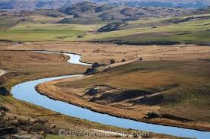

Context details
Candidates will be expected to have an understanding of:
• land use capability
• viticulture
• how water supply affects land use

2.10
Report on the environmental impact of the production of a locally produced
primary product.
4 INT
- Recent dairy conversion in Oamaru, Waiareka creek. Water/soil testing.
- Fertilizer use, water and irrigation.
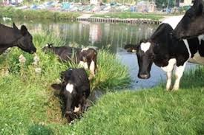

Externals:
2.6 Standard 91294
Title Demonstrate understanding of how NZ commercial management
practices influence livestock growth and development
Version 1
Number of Credits 4
Context details
Candidates will be expected to have an understanding of:
• pigs
• cattle
• sheep.
2.9
Standard 91297 External
Title Demonstrate understanding of land use for primary production in
New Zealand
Version 1
Number of Credits 4
Context details
Candidates will be expected to have an understanding of:
• land use capability
• viticulture
• how water supply affects land use

