New Zealand sheep breeds:

TASK: For each of theses breeds write a description of: (in your own words…cutting/pasting NOT ALLOWED!)

* Characteristics and how common
* Wool
* Meat
* Country suitability
* Breeding lambing
* Body weight

SHEEP BREEDS

|  |
| --- |
|  |
|  |
|  |
|  |
|  |
|  |
|  |
|  |
|  |
|  |

[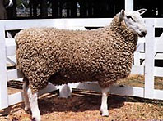](http://www.nzsheep.co.nz/index.php?page=border-leicester)

[**Border Leicester**](http://www.nzsheep.co.nz/index.php?page=border-leicester)

|  |
| --- |
|  |
|  |
|  |
|  |
|  |
|  |
|  |
|  |
|  |
|  |

[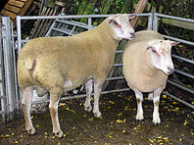](http://www.nzsheep.co.nz/index.php?page=charollais)

[**Charollais**](http://www.nzsheep.co.nz/index.php?page=charollais)

[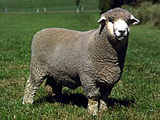](http://www.nzsheep.co.nz/index.php?page=corriedale)  
[**Corriedale**](http://www.nzsheep.co.nz/index.php?page=corriedale)

|  |
| --- |
|  |
|  |
|  |
|  |
|  |
|  |
|  |
|  |
|  |
|  |

|  |
| --- |
|  |
|  |
|  |
|  |
|  |
|  |
|  |
|  |
|  |
|  |

[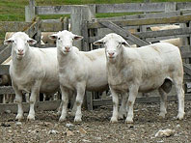](http://www.nzsheep.co.nz/index.php?page=dorper)

[**Dorper**](http://www.nzsheep.co.nz/index.php?page=dorper)

[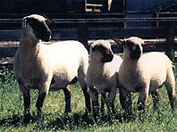](http://www.nzsheep.co.nz/index.php?page=dorset-down)

|  |
| --- |
|  |
|  |
|  |
|  |
|  |
|  |
|  |
|  |
|  |
|  |

[**Dorset Down**](http://www.nzsheep.co.nz/index.php?page=dorset-down)

|  |
| --- |
|  |
|  |
|  |
|  |
|  |
|  |
|  |
|  |
|  |
|  |

[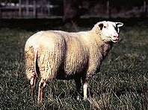](http://www.nzsheep.co.nz/index.php?page=east-friesian)

[**East Friesian**](http://www.nzsheep.co.nz/index.php?page=east-friesian)

[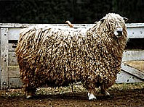](http://www.nzsheep.co.nz/index.php?page=english-leicester)

|  |
| --- |
|  |
|  |
|  |
|  |
|  |
|  |
|  |
|  |
|  |
|  |

|  |
| --- |
|  |
|  |
|  |
|  |
|  |
|  |
|  |
|  |
|  |
|  |

[**English Leicester**](http://www.nzsheep.co.nz/index.php?page=english-leicester)

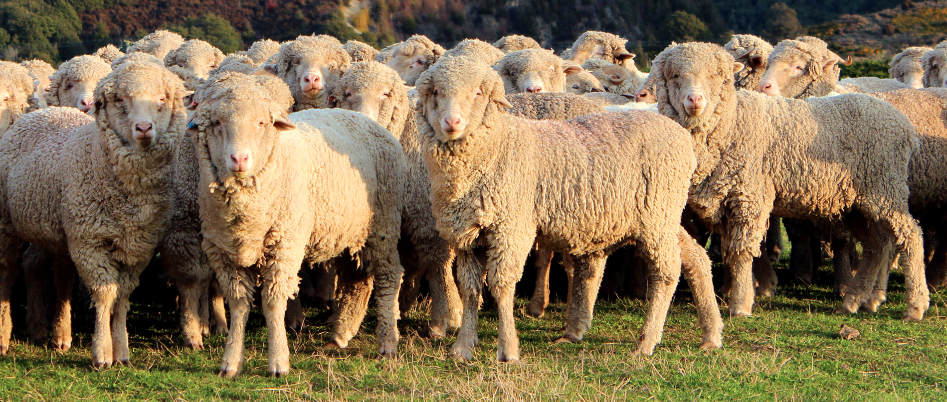

**Merino**

[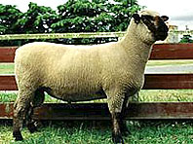](http://www.nzsheep.co.nz/index.php?page=hampshire)

|  |
| --- |
|  |
|  |
|  |
|  |
|  |
|  |
|  |
|  |
|  |
|  |

[**Hampshire**](http://www.nzsheep.co.nz/index.php?page=hampshire)

|  |
| --- |
|  |
|  |
|  |
|  |
|  |
|  |
|  |
|  |
|  |
|  |

[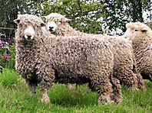](http://www.nzsheep.co.nz/index.php?page=lincoln)

[**Lincoln**](http://www.nzsheep.co.nz/index.php?page=lincoln)

|  |
| --- |
|  |
|  |
|  |
|  |
|  |
|  |
|  |
|  |
|  |
|  |

[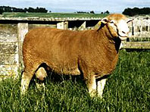](http://www.nzsheep.co.nz/index.php?page=poll-dorset)

[**Poll Dorset & Dorset Horn**](http://www.nzsheep.co.nz/index.php?page=poll-dorset)

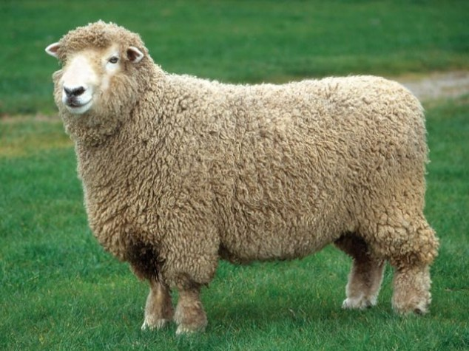

**Romney**

[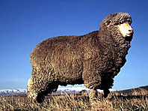](http://www.nzsheep.co.nz/index.php?page=polwarth)

[**Polwarth**](http://www.nzsheep.co.nz/index.php?page=polwarth)

|  |
| --- |
|  |
|  |
|  |
|  |
|  |
|  |
|  |
|  |
|  |
|  |

|  |
| --- |
|  |
|  |
|  |
|  |
|  |
|  |
|  |
|  |
|  |
|  |

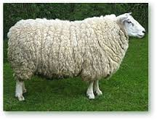

**Coopworth**

|  |
| --- |
|  |
|  |
|  |
|  |
|  |
|  |
|  |
|  |
|  |

|  |
| --- |
|  |
|  |
|  |
|  |
|  |
|  |
|  |
|  |
|  |
|  |

[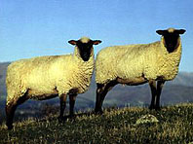](http://www.nzsheep.co.nz/index.php?page=south-suffolk)

[**South Suffolk**](http://www.nzsheep.co.nz/index.php?page=south-suffolk)

|  |
| --- |
|  |
|  |
|  |
|  |
|  |
|  |
|  |
|  |
|  |
|  |

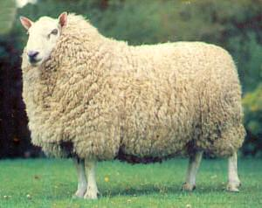

Cheviot

|  |
| --- |
|  |
|  |
|  |
|  |
|  |
|  |
|  |
|  |
|  |
|  |

[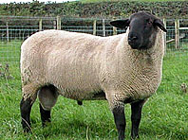](http://www.nzsheep.co.nz/index.php?page=suffolk)

[**Suffolk**](http://www.nzsheep.co.nz/index.php?page=suffolk)

|  |
| --- |
|  |
|  |
|  |
|  |
|  |
|  |
|  |
|  |
|  |
|  |

[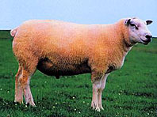](http://www.nzsheep.co.nz/index.php?page=texel)

[**Texel**](http://www.nzsheep.co.nz/index.php?page=texel)

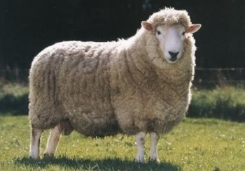

|  |
| --- |
|  |
|  |
|  |
|  |
|  |
|  |
|  |
|  |
|  |
|  |

Perrendale