NITROGEN IN AGRICULTURE:

Introduction
Nitrogen is one of the most abundant elements on earth. It accounts for 78% of the earth’s atmosphere in the form of N2 [1]. Plants require nitrogen for their metabolic processes as well as growth. It is a key component of amino acids, the building blocks of proteins, as well as chlorophyll. However, plants are unable to fulfill their needs with the di-nitrogen available in the earth’s atmosphere. They require nitrogen in the form of nitrate or ammonium, both of which are more complex forms (NH3, NH4, NO2 or NO3) that are found in the soil. There are three ways that the atmospheric nitrogen is converted into nitrate/ammonium that is found in the soil. The first is through atmospheric fixation events such as lightning strikes, rain, and snow, relying upon climatic events. Another alternative is through man-made fertilizers that utilize the Haber process to produce ammonium. Finally, some plants have a symbiotic relationship with diazotrophic bacteria that fix atmospheric nitrogen into ammonium.
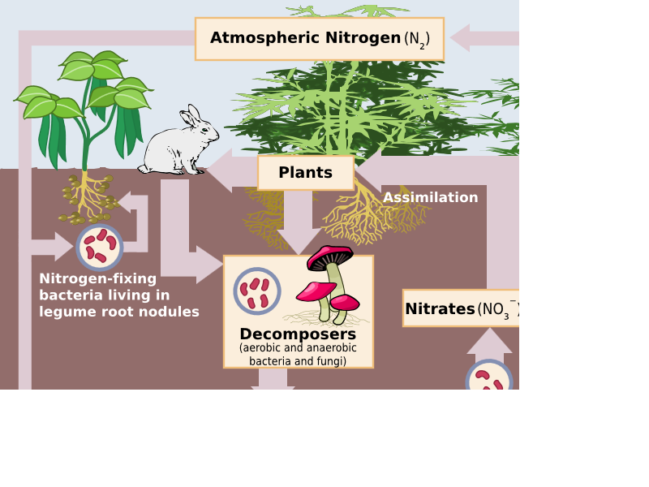
Nitrogen fixation
Diazotrophs are bacteria that contain nitrogenase, the enzyme responsible for biological nitrogen fixation (BNF). Diazotrophs include cyanobacteria, green sulfur bacteria, azotobacteraceae, rhizobia, and frankia.
The reaction for BNF is as follows: N2 + 8 H+ + 8 e− → 2 NH3 + H2
The majority of plants that have a symbiotic relationship with diazotrophs come from the legume family, known formally as Fabacae [3]. These include plants such as clovers, soybeans, alfalfa, lupines, peanuts, and rooibos. Legumes contain root nodules that harbor the diazotrophs, providing them with the anaerobic conditions necessary to fix nitrogen [4]. While the plant lives, most of the fixed nitrogen goes to the plant itself. However, after the death of the plant, the fixed nitrogen is released, acting as a natural fertilizer for the soil and providing usable nitrogen to other plants (non-legumes).

Agricultural uses
The Haber process used in the production of fertilizer, while chemically efficient, requires boiling, cooling, and very high pressure throughout the process. This requires the use of fossil fuels, and results in high costs to farmers. About 2% of the world’s energy goes into the production of fertilizer alone. It must be replaced frequently and represents a strong cost to the environment, both in terms of the amount of energy used up and the negative impacts of fertilizer runoff into rivers and other sensitive ecosystems [5]. Although fertilizer is by far the most common way of providing ammonium to crops, many farmers are already using alternative methods involving nitrogen-fixing bacteria. Some farmers use crop-rotation techniques in which they plant leguminous crops some seasons in order to fertilize the soil for future harvest of other crops. Another method is to plant leguminous plants alongside the crop in question, as long as it doesn’t block out sunlight or hurt the growth of the other crop. Current research is going into finding a diazotroph that is able to fix nitrogen for all types of crops- scientists are looking for an alternative ways to trigger the mechanism on plants that produces the root nodule in order to attract rhizobia or other diazotrophs [6].

Reasons for move to BNF

Yield Concerns
There are a few reasons why there needs to be a move towards more plants being able to fix their own nitrogen. The first reason is the need for increased yields in crops over the next few decades combined with the expensive nature of nitrogen fertilizers. Grain crop yields have increased substantially over the last thirty years while the area of land harvested has stayed relatively flat. For example, in 1975 the area harvest for grains was just over 700 million hectares for a total production of roughly 1,250 metric tonnes. This comes out to a yield of roughly 1.75 tonnes per hectare.[7] In 2010, the total harvested area remained flat around 700 million hectares while the global grain production had risen to roughly 2,500 million metric tonnes. This comes to a yield of roughly 3.5 metric tonnes per hectare, a very significant increase. A lot of the increased in yields can be attributed to increased fertilizer use, in some cases as much as 75%. With the population doubling in the last 30 years, the increase in yield has been essential to our survival.[8] Over the next few decades, the population is expected to rise even further, which will require yields to rise even further.

Costs
Secondly, fertilizer costs are a large part of farmers’ budgets. In 2011, fertilizers for corn and wheat were roughly 20% of a farmer’s budget, compared to less than 10% for soybeans. This is due to the fact that soybeans do not need as much fertilizer because of their symbiotic relationship with nitrogen fixing bacteria. Fertilizer costs have increased nearly 50% in the previous years, putting pressure on farmers to find alternative methods of providing nitrogen to their crops.[9]

Environmental Concerns
Finally, there are environmental costs associated with the excessive use of fertilizer. The nitrogen that is not taken up by plants can “accumulate in soil, water, the atmosphere and coastal oceanic waters [and] contribute to the greenhouse effect, smog, haze, acid rain, coastal ‘dead zones’ and stratospheric ozone depletion.”[10] Crops are only able to harness somewhere between 30% and 50% of the fertilizer that is applied.[11] Fossil fuels are another factor in the environmental costs of fertilizers. Roughly 2% of the world’s fossil fuel consumption is used in producing fertilizers. If major crops can be enhanced to become nitrogen fixers, then the world would use substantially less fossil fuels. We would be able to decrease fertilizer production and limit the cost of transportation to the farmland. We would cut down the costs of fertilizer because the plants would be able to biologically fix nitrogen. The increase in yield that is needed would not be sacrificed, and there would be less excess nitrogen in water and soil because plants that fix nitrogen themselves make the necessary amount.

A major new technology has been developed by The University of Nottingham, which enables all of the world’s crops to take nitrogen from the air rather than expensive and environmentally damaging fertilisers.
The development has been announced in a media release (here) posted on UK Campus.
The statement explains that nitrogen fixation, the process by which nitrogen is converted to ammonia, is vital for plants to survive and grow.
But only a very small number of plants, most notably legumes (such as peas, beans and lentils) have the ability to fix nitrogen from the atmosphere with the help of nitrogen-fixing bacteria.
The vast majority of plants have to obtain nitrogen from the soil, and for most crops being grown across the world, this also means a reliance on synthetic nitrogen fertiliser.
But Professor Edward Cocking, Director of The University of Nottingham’s Centre for Crop Nitrogen Fixation, has developed a unique method of putting nitrogen-fixing bacteria into the cells of plant roots.
His major breakthrough came when he found a specific strain of nitrogen-fixing bacteria in sugar-cane which he discovered could intracellularly colonise all major crop plants. This ground-breaking development potentially provides every cell in the plant with the ability to fix atmospheric nitrogen. The implications for agriculture are enormous as this new technology can provide much of the plant’s nitrogen needs.
Professor Cocking has long recognised there is a critical need to reduce nitrogen pollution caused by nitrogen based fertilisers.

Nitrate pollution is a major problem along with the pollution of the atmosphere by ammonia and oxides of nitrogen.
Nitrate pollution is a health hazard, too, and causes oxygen-depleted ‘dead zones’ in our waterways and oceans. A recent study estimates that that the annual cost of damage caused by nitrogen pollution across Europe is £60 billion — £280 billion a year.
Speaking about the technology, which is known as ‘N-Fix’, Professor Cocking said:
“Helping plants to naturally obtain the nitrogen they need is a key aspect of World Food Security. The world needs to unhook itself from its ever increasing reliance on synthetic nitrogen fertilisers produced from fossil fuels with its high economic costs, its pollution of the environment and its high energy costs.”
N-Fix is neither genetic modification nor bio-engineering. It is a naturally occurring nitrogen-fixing bacteria which takes up and uses nitrogen from the air.
Applied to the cells of plants (intra-cellular) via the seed, it provides every cell in the plant with the ability to fix nitrogen.
Plant seeds are coated with these bacteria in order to create a symbiotic, mutually beneficial relationship and naturally produce nitrogen.
N-Fix is a natural nitrogen seed coating that provides a sustainable solution to fertiliser overuse and Nitrogen pollution.
It is environmentally friendly and can be applied to all crops.
Over the last 10 years, The University of Nottingham has conducted a series of extensive research programmes which have established proof of principal of the technology in the laboratory, growth rooms and glasshouses.

