Pregnancy Testing of Sheep
Using ultrasound scanning technology is a proven, stress-free and accurate method of determining whether ewes are pregnant, and if so, how many lambs they are carrying.
It is recommend that you scan ewes within 95-100 days of the date the ram was introduced, and within 45 days of the date the ram was withdrawn.
- To get the most accurate results the ewes should be brought in the day before the scan and held overnight in a yard so that they have been off grass for at least 6 hours.

Available Diagnostic Options
You can choose one of the following options:
- All triplets, twins, singles and dries.
- Percentage of triplets (the Scanner will call the triplets that are easily seen - this option usually picks up around 60% of triplets), plus all twins, singles and dries.
- All twins, singles and dries.
- Wet or dry.
In addition you can also choose to diagnose:
- Lates (the Scanner will identify late lambing ewes based on the date that you specify);
or
- Cycles (the Scanner will identify ewes according to the 17 day division in which they became pregnant).

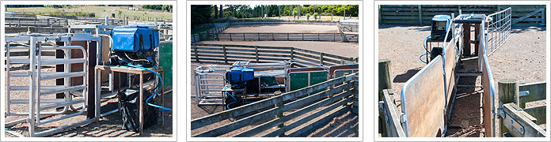

ULTRASOUND PREGNANCY SCANNING
Besides using artificial insemination, commercial sheep farmers use scanning to improve survival and birth weight of lambs. Small lambs at birth are less likely to survive, especially in cold wet weather. A scanning technician can scan over 200 sheep per hour, making it a reasonably inexpensive procedure. Ewes can be scanned to see whether they are carrying one, two or three lambs.
The ewes should be scanned within 95—100 days of when the ram was put in, and within 45 days of the ram being taken out.
For accurate results the ewes should be yarded and off the grass for 6 hours.
The ewes are held in a special crate which gives the operator access from the side to underneath the ewes so they can be scanned.
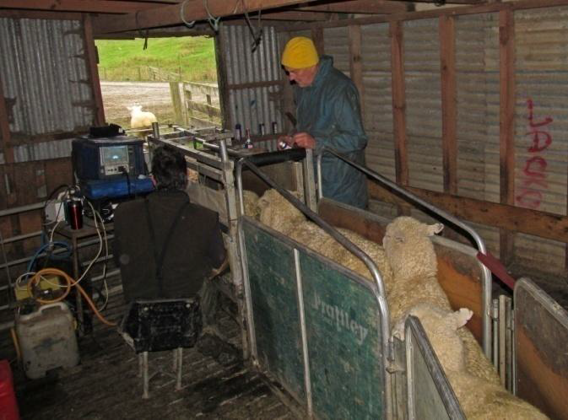

The scanning technician (left) sits on a low chair and places the probe on the belly by the udder.

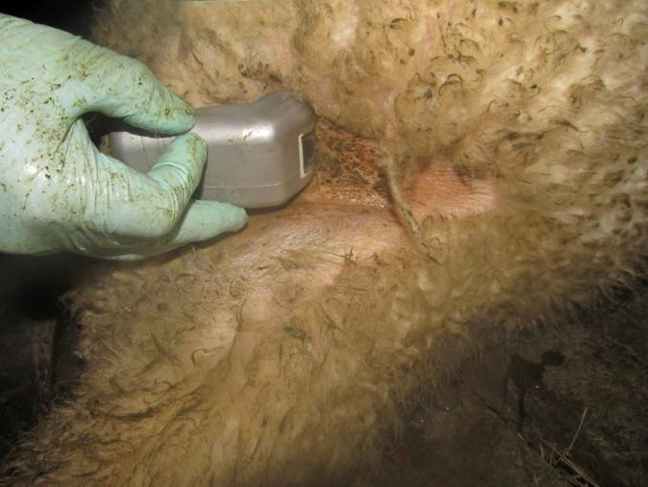 The probe on the bare skin between the udder and the thigh.

The scanner uses an ultrasound head or probe to ‘see’ inside the ewe.
The ultrasound head is connected by cable to a monitor screen which shows the images.
The probe also has a tube attached to spray water on the skin to make good contact for the ultrasound to penetrate.

The scanning technician is checking the monitor screen for the number of lambs in the ewe, or if the ewe is empty (has no lambs).
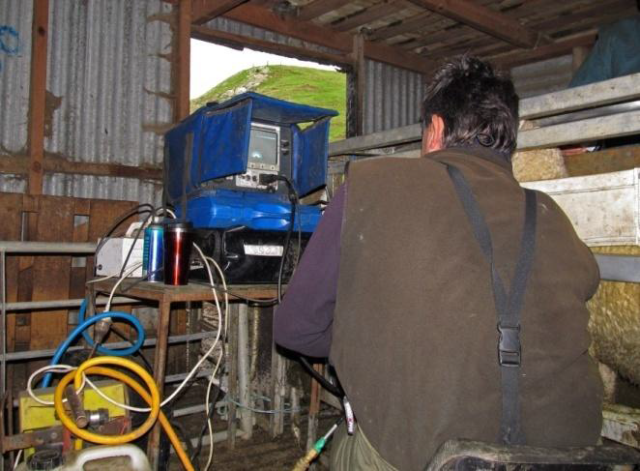
The screen is shaded by the blue panels so it is easy to read.
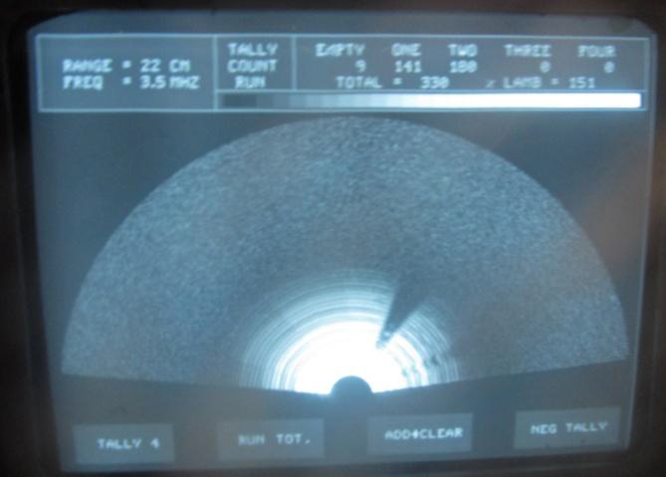 Image on the monitor screen when the probe is not being used.

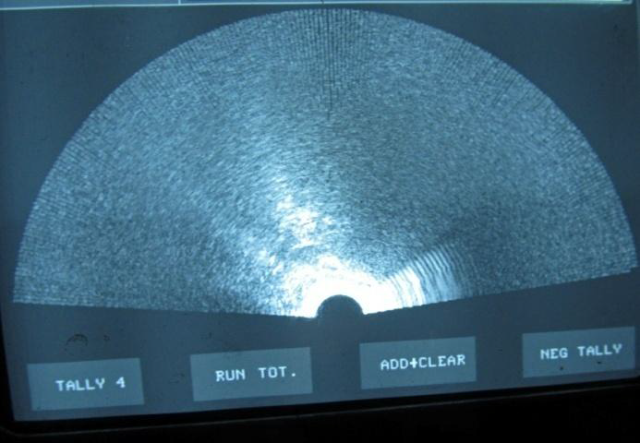

Empty ewe (no lambs).

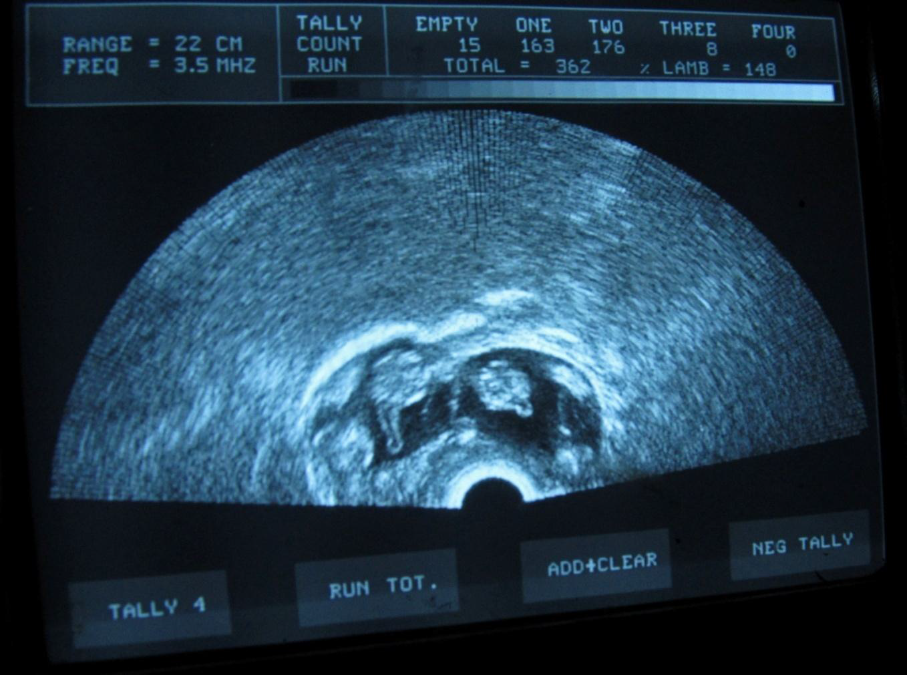

Twin lambs at a very early stage.

The farmer may sell the empty ewes now they are known to be dry rather than keeping them through the winter and not producing a lamb.
The ewes are marked or drafted immediately from the scanning crate according to the number of lambs they are carrying (or if they are empty) and will be grouped into separate mobs.

Dry ewe marked with orange spray raddle.
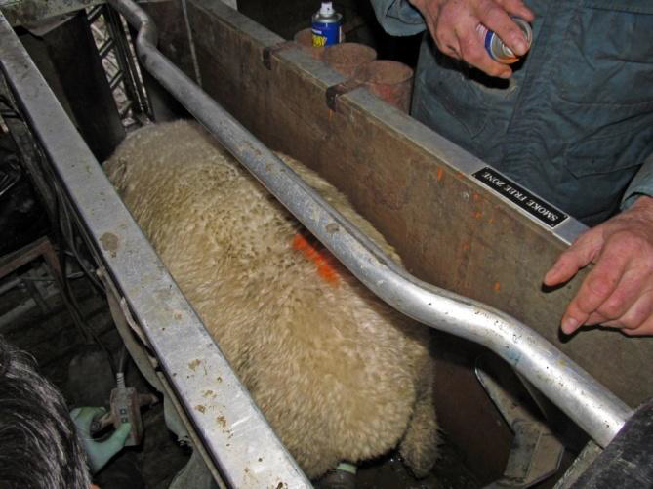
Sheep carrying more lambs are given more food by putting them on better-quality pasture, feeding them winter crops and adjusting stocking rates. In this way, twin and triplet lambs have higher birth weights and are more likely to survive. As well as this, single lambs are less likely to grow too big, avoiding birth problems (dystocia) for ewes carrying singles.
After the lambs are born, ewes with multiples are also fed more, so that they can feed their lambs well. Lactating ewes need to be fed well to produce a good milk supply for their lambs, as twins and triplets will need more milk.

Questions:
- In mid-June a farmer scans the ewes and drafts them into two mobs, single-bearing and twin-bearing ewes. At scanning they weigh about 62kg. The farmer wants the single-bearing ewes to weigh about 65kg, and the twin-bearing ewes about 67kg at lambing time.

- Give two reasons why this farmer feeds the two groups differently.

3. Explain how this would improve the farmer’s profits?

