Set Stocking and Rotational Grazing Management Systems
Rotational grazing and set stocking offer different farm management options to control pasture and ruminant livestock production.
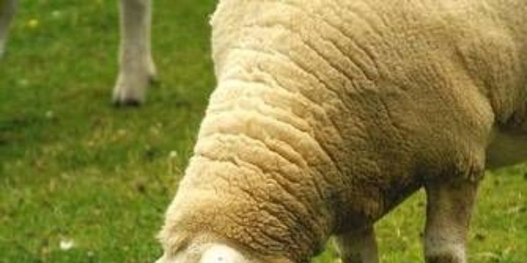
Grazing Sheep (Martin Pettitt)
Grass fed dairy cows are usually farmed using intensive rotational grazing systems. Beef cattle, sheep, goat and deer farmers typically set stock animals during parturition and early lactation, and at other times they are rotationally grazed.

Rotational Grazing
A rotational grazing system involves grazing a group of animals in one paddock at a relatively high stocking rate for a defined period (e.g. a week, five days or two days) then moving them onto another paddock. Pasture quality and growth rates determine the number of paddocks in the rotation. Time grazing any one paddock depends on pasture mass and quality, and feed requirements of the animals.
Different sets of paddocks on a farm may be used to rotate different classes or types of livestock. Rotation length, i.e. the number of days taken for stock to graze all paddocks in the rotation, depends on the class of stock, the number of paddocks in the rotation and the season (which influences the rate and quality of pasture growth).
Advantages include:
- Good pasture utilisation, i.e. animals have less opportunity to select only the best plants or plant parts
- Even pasture quality due to good utilisation and even spread of urine and faeces
- Time is allowed for pasture re-growth in a paddock between one grazing and the next
- Parasite lifecycles are disrupted which helps to reduce livestock parasite burdens

Controlling Grazing Rotation Length
If rotation length is too long, by the time animals return to previously grazed paddocks pasture may become long or rank. Leaves shade each other (reducing photosynthesis) and dead material accumulates resulting in declining pasture mass, pasture quality and animal production. During periods of rapid grass growth, such as spring, the rotation can be shortened by:
- shutting up paddocks for making silage or hay thereby increasing the stocking rate on paddocks left in the rotation
- increasing the stocking rate by buying in extra stock
If rotation is too short, when the animals return to previously grazed paddocks pasture may not have had time to re-grow adequately which may restrict animal growth rates. Further grazing can then reduce pasture mass to very low levels resulting in slower re-growth as there is little leaf left for photosynthesis. By the next grazing there may be even less pasture for stock. Ways to slow the rotation include:
- Reducing the stocking rate e.g. by selling stock
- Feeding supplementary feed, such as silage or hay, so that animal requirements are met without the need to reduce pasture mass to low levels
- Encouraging pasture growth by improving soil fertility e.g. applying fertiliser
Rotational grazing gives farmers greater control over animal intake than set stocking. Intake can be estimated reasonably accurately because high stocking rates means stock are less selective and graze more evenly. Also, pasture does not grow much during the short time that animals are in a paddock therefore the difference between pre- and post-grazing pasture mass is mostly animal intake. Some allowance for pasture growth may need to be taken during fast growth periods in spring and autumn or if stock are in a paddock for more than a couple of days.

Set Stocking
Set stocking involves grazing animals in a paddock at a relatively low stocking rate and only moving them to another paddock occasionally. Stocking rate has to take into account expected pasture growth rates to ensure that pasture is growing at about the same rate as the animals eat it.
Advantages include:
- Less stress on stock from being handled or moved during critical physiological stages, e.g. parturition (calving/lambing)
- Less chance of mis-mothering after parturition
- Low labour requirements, i.e. less time spent moving livestock
- Livestock are able to select preferred pasture plants and plant parts which may raise the quality of the feed consumed compared to the overall quality of the pasture – this may be of benefit during drought periods or on low fertility rangeland
- Less pugging of pastures when soils are wet
Disadvantages include:
- Poor pasture utilisation, and uneven pasture quality and mass, particularly if pasture mass is high, because animals eat the most palatable or preferred pasture components first
- Favoured ‘campsites’ such as shaded or sheltered areas, can result in uneven soil fertility because a high proportion of urine and faeces is deposited in campsites overnight or when animals are resting
- Animal intake and consequently growth rate, is harder to judge as pasture is continually growing during the relatively long time that animals are in a paddock
- Animal health issues may not be noticed as quickly compared to rotational grazing because animals are not regularly shifted, i.e. grazing or sitting animals may not exhibit problems as obviously as when they are walking or running
- If pasture is infected with parasites, set stocked animals are continually exposed to them.
Other grazing systems used for specific livestock feeding purposes include break feeding, strip grazing and creep grazing.

