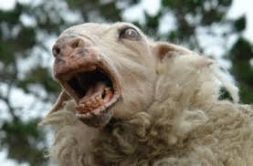
SHEEP NUTS!!!!!
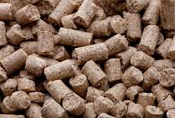

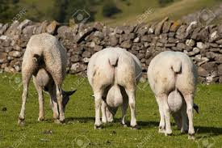

During times of low pasture availability and/or quality, sheep require a good quality supplement to balance nutrient deficiencies.
This should be a digestible feed that provides a high metabolisable energy (Me) and low neutral detergent fibre (nDF), which is important to fill feed gaps and maintain production. It is also important for ewes in late pregnancy as rumen space is limited due to the foetus or foetuses, and this negatively impacts feed intake, particularly if ewes are carrying twins and triplets.
Sheep nuts are designed as a highly digestible feed with high levels of Me to allow energy levels to be maintained while feed intake is decreased.
Keeping ewes in good condition and maintaining nutrition in late pregnancy is important. It prevents wasting diseases such as sleepy sickness, and increases lamb viability and survival, particularly for ewes carrying multiple lambs
Severe under-nutrition during the last trimester of pregnancy can affect wool quality as it impairs the development of secondary wool follicles in the lamb, leading to depressions in the quality and quantity of their wool as mature adults.
The optimum feeding rate depends on pasture availability, age and condition of the sheep. Sheep nuts should typically be fed at 150g/head/day but can be fed at higher rates if needed. if grain or sheep nuts have not be fed previously, then sheep should be started on 50grams/head/day for one week, then gradually built up to the desired daily feeding rate over the following one to two weeks. This allows the rumen to adapt to digesting a higher starch feed and reduces the risk of acidosis. Sheep should always have forage available and have continuous access to clean, fresh water. limiting water intake will depress feed intake and affect production.

