2015, LIBERAL ARTS.
John McGlashan College.
Year 13, Level 3.
Teacher; Glen Clark.
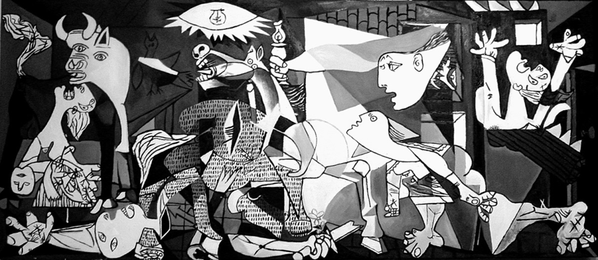

So what is Liberal Arts?
“The liberal arts are those subjects or skills that in classical antiquity were considered essential for a free person (a citizen) to know in order to take an active part in civic life.
In Ancient Greece this included participating in public debate, defending oneself in court, serving on juries, and most importantly, military service (slaves and resident aliens were by definition excluded from the duties and responsibilities of citizenship). The aim of these studies was to produce a virtuous, knowledgeable, and articulate person.”
A bit has changed since then, during the Renaissance (c.1400-1600) the Liberal Arts was re-established and also had more emphasis on the sciences, mathematics, geometry, art, philosophy, astronomy, music, poetry… basically on what is was to be ‘human’. A true ‘Renaissance man’ involved himself in a variety of these things. Da Vinci encompasses the term perfectly.
My programme aims to provide students with a variety too… philosophy, history, media and processes, painting, sculpture, film and texts. Most of which is delivered with an emphasis on the visual…learning through our eyes and being able to analyse and articulate what we see.
Throw in some field trips to galleries and museums to see and experience relevant things and I think it is a very exciting programme.

SO what are we going to do this year? Each box represents a week…
Term one:

TERM TWO:

TERM 3:

Term 4:

In sequential order (start of year to Finish):

Term one:
- An intro to Modernism…What happened (1900’s)
- A look at the past…Classical, Renaissance, Romanticism etc
- Pre-Modernists- Cezanne, Van Gogh, Monet etc
- Cubism
- How to analyse a painting…Gallery visit (John Neumagen). (3 periods)
- “The shock of the New” Analysing texts. Between Cubism and Futurism. Delaunay, Leger , German Expressionism, Dada etc AS 3.8

Term Two:
- Media and Processes…Oil, Collage, sculpture/assemblage. Analytical and synthetic cubism. Picasso Braque Gris. A/S 3.4.
- Media…Meaning in a Film. Midnight in Paris. A look at Postmodernism in Film. What is Post-Modernism? How is it expressed in the film and how does it help convey the meaning? Media AS 3.2
- Futurism and Theories in art. The Futurist Manifesto, Einsteins theory of relativity, Feminism, Unconscious, technology. Boccioni, Balla, Carra. AS 3.7

Term Three:
- Media: Development of an aspect of Media and the rise of Nazi Power. Propaganda. Radio/posters/magazines. Media AS 3.7
- Context: Practice essay questions for external. Link between art and context. Analysing a painting and structuring an essay. AS 3.
- Gallery Visit

Term Four:
- Exam preparation AS 3.3

Liberal Arts Achievement Standard Matrix: Level three. 2015

 | Title of Standard/Topic | Number of credits | Internal/External | Assessment format: | Context of the Standard: | Learning Outcomes
Art History 3.3 | Examine the relationship(s) between art and context. | 4 | External | Exam Essay | Links between Modernist art between 1900-1940 and its context. | How art goes hand in hand with the era that shaped it (zeitgeist).
Art History 3.7 | Examine the relationship(s) between a theory and art works | 4 | Internal | Written essay in the form of an interview answering specified questions | Futurism. Italian Fascism.  Manifestoes and modernist theories | Einstein and relativity  Darwinism and evolution/religion  Futurist manifesto
Art History 3.4 | Examine the impact of media and processes on art works. | 4 | Internal | Presentation, written essay with visual components, poster. | Cubism (analytic, synthetic and sculpture) | “New techniques” and the Avante Garde.  How and why does the media used impact how the final work is interpreted or delivered?  Compare, contrast, analyse and explain.
Art History 3.8 | Analyse texts about art | 4 | Internal | Written essay | Introduction to Early Modernism | “The Shock of the New”- Robert Hughes.  Why is this text successful/unsuccessful? Compare and contrast it to other texts on Modern art. What is the author trying to say?
Media Studies 3.2 | Demonstrate understanding of the meaning of a media text through different readings | 3 | Internal | Written essay | Postmodern Film study. “Midnight in Paris” | What defines/aspects of “Post-modern” in film?
Media Studies 3.7 | Demonstrate understanding of a significant development in the media | 3 | Internal | Presentation, written essay | Propaganda and art in Nazi Germany. | What new media developments enabled the propaganda message to be delivered so effectively.? Ie radio, film

Year 13, Liberal Arts. 2013. | Achievement standards taught. |  | Credits
Art History
AS91485 (3.4) | Examine the impact of media and processes on art works | Internal | 4
AS91489 (3.8) | Analyse texts about art | Internal | 4
AS91488(3.7) | Examine the relationship(s) between a theory and art works | Internal | 4
AS91484(3.3) | Examine the relationship(s) between art and context | External | 4
Media studies
AS91491 (3.2) | Demonstrate understanding of the meaning of a media text through different readings | Internal | 3
AS91496 (3.7) | Demonstrate understanding of a significant development in the media | Internal | 3

Area of Study: Early Modernism 1900–1940
candidates will be expected to use art-historical terminology to discuss the formal elements and characteristics of the following styles: Cubism, Orphism, Futurism, Fauvism, Expressionism, Die Brucke, Der Blaue Reiter, De Stilj, Dada, Surrealism.
Plates will be selected from the following:
Artists: Picasso, Sonia Delaunay, Boccioni, Mondrian, Brancusi, Matisse, Kandinsky, Kirchner, Kollwitz, Beckmann, Duchamp, Hoch, Ernst, Miro, Magritte, Dali.

Questions will be drawn from the following:

Meanings
- Personal experiences, the unconscious; chance, automatism and dreams.
- Change: modernity, urbanisation, science
- War, suffering and violence
- Cultural interactions: primitivism, the return to nature, internationalism
- Philosophy and spirituality: Christianity, utopianism, theosophy, Nietzsche, nihilism.

Contexts (Europe)
- Modernity: technology, the modern state, urbanisation, social and class change, social mobility
- Political contexts: war, nationalism, socialism and communism
- Economic contexts: consumerism, prosperity and the Depression
- The Self, Freud and the unconscious
- Cultural interactions.

Developments in the media
- How did WW2 effect Modernism? Hitlers condemnation of ‘Degenerate Art’.
- How did developments in the media effect the spread of Nazi ideas? Radio, film, photography, print.
Post-modernism 1960-present day:
- Postmodernism, Postmodern film and “Midnight in Paris (Analysing meaning).

Outcomes:
Students who participate satisfactorily in this course will improve in their ability to:-
- Understand and critically respond to a range of works of art and art movements.
- Use research and analysis to investigate contexts, meanings, intentions and technological influences related to the making and valuing of art works and media.
- Understand the influences of ideas, cultures and contexts across time.
- Communicate and express research and ideas effectively.

THIS COURSE IS A MIXTURE OF 16 CREDITS IN ART HISTORY AND 6 IN MEDIA STUDIES, THEREFORE ART HISTORY IS THE UE APPROVED SUBJECT (14 CREDITS MIN, IN THREE APPROVED SUBJECT AREAS). PLEASE REMEMBER THIS, IT IS ESPECIALLY IMPORTANT TO ACHIEVE EACH ART HISTORY ACHIEVEMENT STANDARD.

FUTURE STUDIES / CAREER OPTIONS:
The course is useful for those intending to study humanities at university. The course is a specialised one and leads on to university courses in art history, classical studies, media studies, literature, film/media studies. It is a valuable stepping stone to any profession that requires sophisticated communication ie. Law…. or to develop a well-rounded man of the world!

School policies:
Resubmissions will only be granted if a student has made a significant effort and has missed out by a close margin to a grade. No extra advice, teaching or guidance can be offered as this deems it unfair.
Extensions can be granted only with a valid note explaining reasons and application form filled out.

