Task:

Sigmund Freud.
Carl Jung
Albert Einstein.
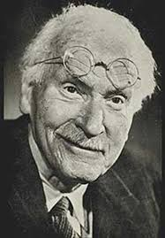 Jung.

- Who were these men?

- What theories have they contributed? In a ‘nutshell’ write a description of their ideas.

- How might these ideas be evident in the Art created during their time?

