Impact of Dairy Farming on Water Quality
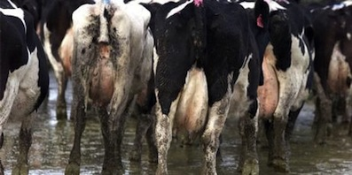
Source:news.ecocentre.co.nz
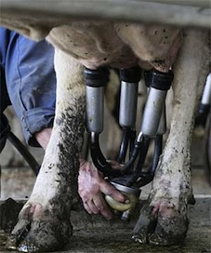
Source:www.stuff.co.nz

Contents
[hide]
- 1 Introduction
  - 1.1 Source Contamination
  - 1.2 Stakeholders of the Issue
  - 1.3 Economic
- 2 Pressures
  - 2.1 Agricultural Waste
    - 2.1.1 Why is this an issue
  - 2.2 Economic Development
- 3 Indicators
  - 3.1 Otago Regional Council Water Quality Plan Change 6a
  - 3.2 Agricultural Waste in Waterways
- 4 Case Study: Waiareka Creek, Kakanui Catchment
  - 4.1 Introduction
  - 4.2 Dairying farming and water quality within the area
  - 4.3 Trends
    - 4.3.1 E. Coli Levels
    - 4.3.2 Nitrogen
    - 4.3.3 Phosphorus
    - 4.3.4 Ammoniacal nitrogen
  - 4.4 Conclusions
  - 4.5 Where to now?
- 5 Repsonses
  - 5.1 Riparian Planting and Barrier Protection
  - 5.2 Irrigation Protocols
    - 5.2.1 Irrigation Systems
    - 5.2.2 Weather Stations
    - 5.2.3 Variable Rate Irrigation
  - 5.3 Education
- 6 References

Introduction
Agriculture, in particular dairy farming, is having a considerable impact on the waterways of New Zealand. It is the relatively recent land use changes that are contributing to the degradation of water quality in New Zealand's waterways. Historically, land in New Zealand was dominated by sheep, beef and cropping, and the intensification of dairy farming and developments in technology are contributing to the increase in contaminants in streams and rivers. Sediment runoff, nutrient loss and animal excrement disposal some are the biggest polluters of waterways from agricultural practices, yet are generally of non-point source contamination (Monaghan, et al., 2007; Quinn & Stroud, 2002, Buck et al., 2004). It is the recent changes in land use that are contributing greatly to the increase in contamination of streams and rivers (Monaghan et al., 2007; Hamill & McBride, 2003). The degradation of water quality has implications for human health (from drinking contaminated water and pursuing recreational activities in contaminated waterways), and can be greatly detrimental to health over time. The quality of water quality can be determined by levels ofEscherichia coli (E. coli), cyanobacteria, nitrates, and phosphates.
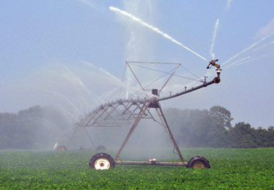
Irrigation system found in Canterbury and across New Zealand, Source:www.usgs.gov
This page has many aspects to cover the water quality degradation that occurs from intensified dairy farming. By following a pressures-indicators-responses framework, the impact of dairy farming can be clearly seen. The pressures that agriculture and dairy farming put on waterways; any indicators that would show a degradation in water quality as a result of dairy farming in the area; any potential trends that show increasing degradation or improving water quality; levels of indicatorsin the case study area of the Waiareka Creek within the Kakanui catchment of North Otago; and the responses could be implemented to reduce the contamination of waterways by dairy farming activities are all things that are considered here.
Typical New Zealand Freisian Dairy Cow, Source:makesmeglow.blogspot.co.nz

Source Contamination
Dairy farming has a particular effect on the quality of waterways due to the extensive application of nitrogen and phosphorus fertilizers, and the subsequent leaching of soils from irrigation of land (and in some cases, the over-application of both water and fertilizers). There is also the issue of animals being allowed access to streams and rivers

Stakeholders of the Issue
Local communities also have a right to be concerned with the quality of water in their region, as users of the waterways (Hamill & McBride, 2003), as do the farmers, fishermen/women, the dairying industry (in particular, Fonterra), regional and national government, environmentalist groups, Department of Conservation (DOC) and Fish and Game New Zealand. The polluting of streams and rivers also contributes to the smear on the ‘clean, green New Zealand’ idea and campaign that is fought so hard for (Memon & Selsky, 2004). Contamination of waterways from dairy farming comes from both non-point source contamination (leaching of nutrient and faecal matter from pasture) and direct point sources (animals crossing and spending time in waterways). There are various mitigation strategies available for improving water quality of streams and rivers in New Zealand and across the globe, and some are of considerable importance to dairy farms. These mitigation strategies would need to consider both environmental and economic costs and benefits in order to be effective and sustainable ((Monaghan et al., 2007).

Economic
Dairy farming is a very important industry to the New Zealand economy. It is an industry that has been growing steadily for the last few decades. The numbers of cows in New Zealand have increased from 2,060,898 in 1981 to 4,528,736 in 2011 (DairyNZ, 2011). The total amount eurned by New Zealand-based dairy firms is approximately NZ$18 billion (Coriolis, 2010). 95% of the milk produced in New Zealand is exported making the dairy sector responsible for around one third of the country’s exports (Ministry for Primary Industries, 2013). Dairy exports represented 27% of the total $41 billion earn in merchandise exported in 2009 (Coriolis, 2010).

Pressures
Dairy farming in New Zealand can have a large effect on the natural state of the environment. Previous studies have shown that larger, more intense dairying systems tend to have a higher risk of environmental damage (OECD, Sustainable Agriculture). It is known that dairy farming does have an influence on the surrounding environment, therefore, when there is a large dairy farming system there is consequently a large environmental effect. In general the leading impacts on the environment from dairy farming include gas emissions, nutrient leaching and land use intensification (OECD, Sustainable Agriculture). The main way of accessing the effect of dairy farming is to analyze the E-coil levels in the surrounding water ways, along with other nutrient measures such as nitrogen and phosphate. This is shown in the case study via the results from the 2012 Kakanui catchment report.

Agricultural Waste
Agricultural waste is in waterways is mainly attributed to excess water and nutrients (fertilizers and effluent) from farm land entering water ways and leading to environmental degradation.It is difficult to detect waste miss-management as it is often non-point source contamination. Faecal contaminants are an issue for every farmer, the distribution of waste from the dairy shed and from the cows in the paddock is a constant pressure unlike fertilizers where application can be restricted.
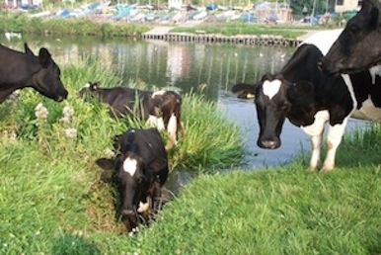
Cows trampling plants and riparian zones, and adding faecal matter to waterways, Source: i.thelocalpeople.co.uk

Why is this an issue
Faceal contamination reduces the quality of the water for drinking and recreational purposes. Increased levels of E. coli is directly associated with faecal contamination, leading to illness to those who come in contact with the water.
The increase of nutrients (particularly nitrogen and phosphorus) can also be linked to faecal contamination. Increase of these nutrients can induce eutrophication, the most common form being cyanobaterial blooms (blue-green algeal blooms). This initially causes an issue by out competing other photosynthetic organisms and releasing toxins toxic to vertebrate species. Secondly when the bloom runs out of resources the dead bloom rots reducing the oxygen available in the ecosystem leading to the death of fish.
The aesthetic qualities of the water ways can also reduced. The increase of the contaminants and plant life decrease the clarity of the water. And the toxic cyanobacteria reduces wild life and carcasses can be found in and around the water.

Economic Development
As one of the biggest industries for the New Zealand economy it is important to maintain and uphold environmentally sustainable practices. With the lucrative money the industry gets from its supply to around 151 countries (most importantly china) it is becoming more and more cost efficient (Ministry for primary, 2013). Along with the growing cow numbers, the numbers of herds have been decreasing but the herd sizes have been increasing. This has meant the number of cows per hectare has risen from 2.7 in 1981 to 2.76 in 2011 (dairyNZ, 2011). This has been greatly helped along by the introduction of irrigation. With this increasing pressure on the environment the risk and amount of pollution and damage to it is getting higher. This can seriously harm the clean green image New Zealand has so strongly invested in if proper environmental management procedures are not cared out correctly. Harm to this could greatly hinder other sectors like tourism.

Indicators
In New Zealand, there are two national guidelines that are commonly used in assessing nutrient concentrations within rivers:
The first one is known as the New Zealand Periphyton guidelines, which provides a range of suggested thresholds that are related to flow conditions for dissolved nitrogen and phosphorus concentrations that are required to control the periphyton growth (Biggs, 2000). During high flow event such as a flood it is known that these events tend to scour out any periphyton growth. In relation to the Kakanui catchment the guidelines are 0.075 mg/l soluble inorganic nitrogen (NNN) and 0.006 mg/l DRP.
The second guideline is authorized by the ANZECC, which provides default trigger values for total and dissolved nitrogen and phosphorus for assessing the risk of adverse effects in slightly disturbed ecosystems (ANZECC, 2000). These trigger values are based on the 80th percentile of a distribution in relation to reference data. For lowland rivers such as the Waiareka creek the values are 0.614 mg/l for total nitrogen and 0.033 mg/l for total phosphorous.
The Australian and New Zealand Conversation Council (ANZECC) provides guidelines for water management.Many of the guidelines in use are comprised of overseas guidelines, and are in some ways ineffective and inappropriate for New Zealand and Australia. New Zealand does not have its own guidelines for water quality. Many resources for ANZECC and the water quality guidelines do not pertain to New Zealand waterways, which makes it difficult for local and regional councils to put in place effective water quality standards. Without regulations on the substances that can be discharged into New Zealand's rivers, they can not be properly protected from agricultural, industrial and urban activities that may release harmful and unwanted substances into waterways.

Otago Regional Council Water Quality Plan Change 6a
Recent changes to the Otago Regional Council's Plan 6a (regarding water quality and the effect that rural land has on water) have resulted from the Ministry for the Environment's ‘State of the Environment Report on Surface Water Quality in Otago’ that was released in 2012. The Ministry for the Environment's ‘National Water Policy’ have lead to changes in Plan 6a, and was met by large contention from many concerned groups (the Otago Regional Council received 334 submissions regarding the proposed plan change!). Those with particular interest in the changes, and considerable contrasting views on the changes are the Otago Fish and Game Council, and the Federated Farmers. Both groups identified that there was an issue with degradation of water quality, but had differing views on how this should be dealt with. The Federated Farmers were concerned with the pressure this would place on farmers and claimed that the nitrogen restrictions would force some farmers into bankruptcy. The Fish and Game Council supported the changes, but had concerns with how discharges and contamination would be monitored and controlled.

Agricultural Waste in Waterways
Agricultural waste into waterways can have a considerable negative effect on the water, the ecology of the stream and its appropriateness for human activity. The Ministry of Health has provided a framework of components that are not suitable to be in rivers that are used for drinking water, and the effectiveness of treatment plants to remove harmful substances from the water. There is also a document on the freshwater guidelines of cyanobacteria in water of recreational use.

Case Study: Waiareka Creek, Kakanui Catchment

Introduction
The Kakanui catchment is an area located in North Otago covering around 894Km2. It is confined in the north by rolling hills, in the east by the Pacific Ocean and in the west and south by the Kakanui Mountains and Pisgah Spur (Ozanne & Wilson, 2013). The Waiareka Creek is one of three main rivers contributing to the Kakanui river catchment and is a prime example that illustrates the effects of dairy farming irrigation on water quality.
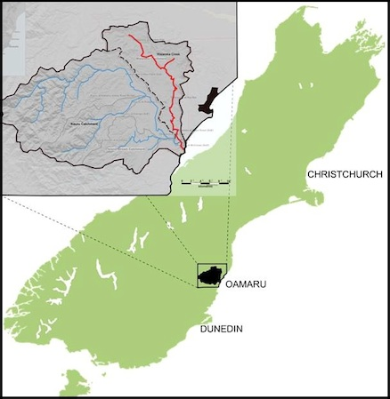
South Island, highlighting the location of the Kakanui Catchment (outlined and in blue) and Waiareka Stream (in red)
The Waiareka creek covers an area the size of 213 km² to the east of Oamaru were it weaves its way from the queen’s flats to Kakanui Estuary where it enters the Kakanui River (Ozanne & Wilson, 2013). This can be seen in the map figure to the left. The rivers gradient is relatively flat with the slop being often below 2⁰ in the lowlands (Ozanne & Wilson, 2013). It is mainly formed on limestone and due to its high porosity, limits the Waiareka contributories for example ground water (Ozanne & Wilson, 2013).
The Kakanui catchment is dominated by a range of land uses such as beef, sheep and deer farming. In recent years the area has seen a particular increasing trend in dairy farming (Ozanne & Wilson, 2013). The Farming practices undertaken in North Otago were originally wheat dominated (a crop that thrived in the dry climate) however it has shifted over the last century to predominantly pastoral farming (Milmine, 2000).
The soils found around the Kakanui catchment are mainly that of Pallic soil with some Melanic soil (McDowell & Weerden, 2011). Pallic soil is characterized by having a high soil bulk density (> 1.3gcm ̄ᶟ), imperfect drainage, moderate fertility and a fragipan (McDowell & Weerden, 2011). These characteristics combined with irrigation can see a large quantity of water runoff produced. With the addition of fertilizer and fertile soils, nutrient loss to this runoff can have negative effects on the surrounding ground and rivers water (Waiareka Creek).
The increase in dairying was brought about by the introduction of water irrigation into the Waiareka Creek catchment in 2006 (McDowell & Weerden, 2011). The areas of land being used for dairying or dairy support activities have increased from 2075 ha prior to irrigation, to 5820 ha (Ozanne & Wilson, 2013). The shift into dairy farming within the irrigated land has been estimated to be about 60% (Ozanne & Wilson, 2013). Were as the change to dairy farming as a land use in the entire Waiareka catchment has risen 25% (2010) (Ozanne & Wilson, 2013).
As this area is prone to drought, irrigation sourced from the river and ground water is heavily used (Milmine, 2000). Water is taken from the rivers and shallow aquifers to be used for a wide range of purposes including rural stock, household water and for small townships as well as rural water schemes (Milmine, 2000). This has recently raised concern about the agricultural intensification and subsequent degradation of the surrounding water quality (Ozanne & Wilson, 2013). Places in the catchment where dairy farm conversions are prevalent are seeing stress put on the naturally good water quality (Ozanne & Wilson, 2013). With the land-use intensification accruing around Waiareka Creek, it has experienced increases in its N and P nutrient concentrations (Ozanne & Wilson, 2013).

Dairying farming and water quality within the area
Dairy farming within the Otago region is a significant land use and with any type of agricultural activity there are the risks involved with water quality. Waiareka Creek enters the Kakanui River just upstream of the Kakanui Estuary. Main reason for a low water quality measurement is usually due to not proper effluent management on the farms. Luckily the Otago Regional Council provides guidelines that each dairy farm must comply with. Such as low rate effluent application systems are strongly advised (Otago Regional Council, (a)).
The amount of land in hectares (ha) used for farming reasons before irrigation and after irrigation occurred within the area.
 | Dairy | Dairy Support | Sheep | Beef | Deer | Arable | Other
Before Irrigation | 2,075 | 1,211 | 5,199 | 179 | 0 | 1,241 | 27
After Irrigation | 5,820 | 933 | 1,023 | 883 | 60 | 1,193 | 19
From the table above it clearly shows that, on the irrigated land within the Waiareka catchment, dairying has increased by 180% (from 2075 ha prior to irrigation to 5820 ha following irrigation). The irrigation company estimates that about 60% of land irrigated is now used in dairying or for dairy support. This is a large percentage of irrigation coming from one farm type alone (Otago Regional Council, (b)).
Water quality management is significant within the Kakanui catchment due to the Waiareka creek containing a high profile available water capacity (PAW). The soils within the Waiareka creek also have a low soil drainage rate which in turn means that the if the water quality is low it will take a longer time to ‘flush’ out the bad toxins. Following this the substrata in the Waiareka creek are also less permeable and naturally silty (Otago Regional Council, (b)).

Trends

E. Coli Levels
The most commonly used indicator for assessing for faecal contamination within water ways is E. coli. Faecal contamination is a major health risk to humans and other species if they come in contact with a significant amount of faecal matter. Faecal matter can make its way into water ways via runoff from the land or effluent pond discharges or stocks defecting directly into the waterways, all of these methods are primarily related to dairy farming. E. coli is a faecal coliform bacterium that originates in the gut of warm bodied animals and indicates the presents of other potentially harmful microbes.
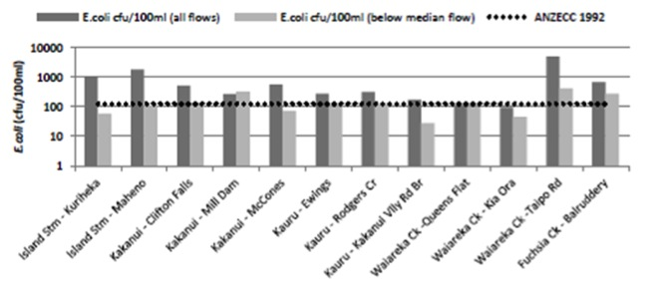
The ANZECC guideline for E. coli levels in rivers is 126 E-coli per 100ml. The E. coli graph shows that during the study carried out within the Kakanui catchment between September 2011 and July 2012 at twelve sites including three sites within the Waiareka creek. As shown all of the sites have a measurement of E. coli that is above the ANZECC 19992 guideline. In particular the Waiareka creek at Taipo road end is significantly over the ANZECC 1992 guideline (Otago Regional Council, (b)).
One of the major contributors to bacterial contamination is probably that of effluent irrigation when soils are at or near saturation. As a rule of thumb, irrigation has been said to not exceed the water-storage capacity of the soil (Otago Regional Council, (b)). If the irrigation level rises above the water-storage capacity of the soil this will result in a toxic river that will be more susceptible to algae blooms. Overall dairy farming is a major contributor to the E. coli levels within rivers in New Zealand.

Nitrogen
Nitrogen is fundamental to life and therefore, can be found in many forms including inorganic substances such as nitrogen gas (N2) and organic forms such as proteins found living in cells (Otago Regional Council, (b)). Because of this the level of nitrogen within water ways is essential for all types of life that come in contact with the water including invertebrates and also cows. As shown in the nitrogen figure below, all of the Waiareka creek sites exceeded the recommend ANZECC guidelines for the level of nitrogen. This means that the effect of irrigation and effluent disposal is particularly bad in this area of the Kakanui catchment.
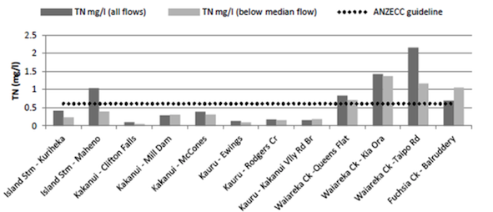

Phosphorus
Phosphorus is a generally natural substance that is particully foned of soil particles. The ANZECC guideline for phosphorus is 0.033 mg/l and again from the phosphorus figure below it can be seen that Waiareka creek has shown measurments above this threshold (Otago Regional Council, (b)). Since nitrogen and phosphuros are enfluenced by similar factors such as irrigation and effulent disposial it is only obvious that they should coninside within their results. With the waiareka creek having heavier soils they are influenced more by direct effluent run-off where as in the other parts of the kakanui river has generally lighter riparian gravels allowing indirect influtration.
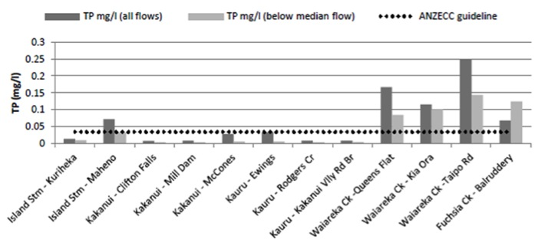

Ammoniacal nitrogen
In farm land catchments high concentrations of Ammoniacal nitrogen are the result of direct influence from effluent discharge, paddock run-off discharge and stock access to the rivers. The figure of ammoniacal nitrogen below shows that none of the 12 sites were over the ANZECC guideline for Ammoniacal nitrogen in fact none of them were even close. Therefore, there could still be hope for the Kakanui catchment area to recover if the proper precautions are made.
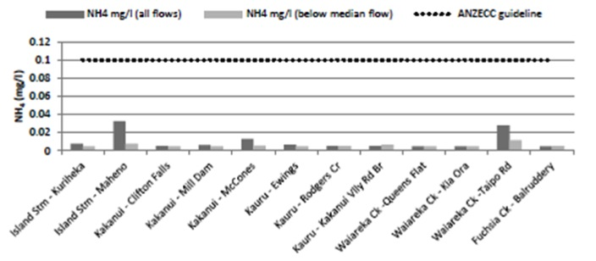

Conclusions
In the Kakanui catchment, changes in land use, especially in the mid- and lower catchment where dairy farm conversions are prevalent, this is putting pressure on the generally good water quality. Since land-use intensification, Waiareka Creek has experienced increases in Nitrogen and Phosphorus nutrient concentrations. As a result of the input of high Nitrogen, the Waiareka creek may not be able to achieve low enough concentrations of Nitrogen to prevent prolific algal growth. Waiareka Creek enters the Kakanui River just upstream of the Kakanui Estuary. The combination of nutrient-rich water from both the Kakanui (Nitrogen) and Waiareka Creek (Phosphorus and Nitrogen) is likely to stimulate algae blooms in the estuary as well.

Where to now?
The results from (Otago Regional Council (b)) will be useful in guiding future policy decisions and the promoting of good practice among communities and other stakeholders. This will hopefully with any luck maintain and enhance water quality in and around the Kakanui catchment.

Repsonses
Mitigation strategies need to be assessed on a farm by farm basis. Soil type, topography, geology, climate and stock numbers all impact on designing the best procedures for environmentally friendly practices.
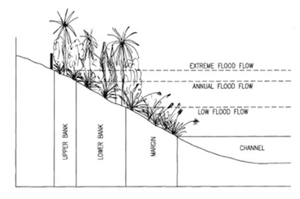
Riparian margins can be grouped into three distinct zones for planting purposes- upper bank, lower bank and margin

Riparian Planting and Barrier Protection
Barrier protection of water ways restricts point source contamination of water ways. By constructing fencing as a physical barrier for stock entering water ways it prevents direct faecal contamination and degradation of natural ecosystems. Every waterway is different and the distance from the water fencing should be built to prevent environmental damage is dependent on the area.
Riparian planting is re-establishment of plants in a riparian zone to help create an ecosystem. The riparian zone is the area adjacent to the water way and is the interface between water and land. The riparian zone can be broken into three sections: upper bank, lower bank and margin.
Riparian planting acts as a filter between farm land and the water way to prevent non-point source contamination. Native planting is preferable as it provides habitats for native wildlife, which are often restricted by farming practices in an area. Native planting is also aesthetically pleasing which assists in maintaining New Zealand’s ‘clean green’ image. It is advised by the Otago Regional Council that grass margins are an appropriate for riparian management. This method however does not encourage native populations and can encourage ‘weed’ species, such as gorse on the boundaries of farms. Grass margins are also not as effective as natives at filtering contaminants before they reach the water body. Selection of species for the riparian zone is dependent on the size of the zone with each separate division of the riparian area supporting different species.
Establishment of barrier protection and riparian planting requires careful management during the first few years of development, but are not labour intensive after establishment. Observation of the area is important to determine the boundaries of the riparian zone and, consequently, the best position for fencing. Management of weed species is also important to ensure the success of native plant succession. Biological control through blanket spraying of herbicides in the area prior to planting and spot spraying post planting is the most effective and economically viable option for weed management. Pest control through insecticides will also aid in the success of plants. Planting of propagated plants are more likely to survive in the area than direct sowing methods. Advice on when to plant the different species should be sought from the supplier as plants have different tolerances (i.e. frost hardy plants can with stand re-planting in the autumn and winter months). The space required by the plants is also dependent on the expected adult size of the plant.
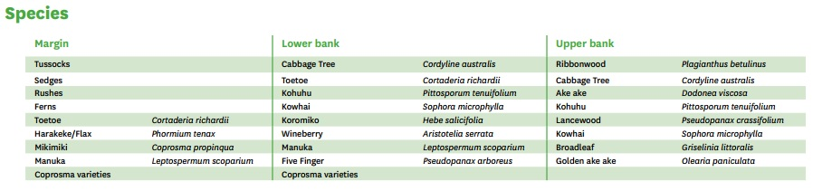
List of suitable plants for each area of the riparian zone in the South Island, native plant species is dependent on the region.

Irrigation Protocols
Different irrigation systems are designed for different terrains and farm types, it is important to research the best suited irrigation system for the area to prevent over or under application. Waste water is often also distributed through these systems, and incorrect application is the leading cause of non-point source water way contamination.

Irrigation Systems
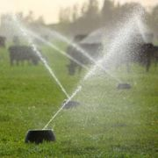
Source:cloake.co.nz
Irrigation systems such as centre pivots are often inappropriate for areas with rolling hill topography as it does not compensate for valleys and troughs creating runoff. In these situations K-line irrigation is preferable as the amount of water applied can be managed more precisely. K-line irrigation is very labour intensive and dependent on the farm size can require a full time employee at the peak of summer. K-line are also not appropriate for waste dispersal therefore a secondary system needs to be used such as micro sprinklers along shelter belts or hard hosed irrigator on flatter sections of the farm.
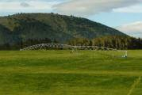
Source:www.waterforce.co.nz
On flat land centre pivot systems are more effective as there is less chance of runoff and ponding. Hard hose travelling irrigators are also of beneficial in these conditions. Both systems can be used to for waste distribution. Flood irrigation methods can be used in flat arid areas with sheep farming, but due to the large amounts of waste associated with dairy this can lead to direct faecal contamination of nearby waterways. The pressure of water and the ‘nozzle’ size of the chosen irrigation system can vary and it is important to assess this when designing a rotation plan. Those areas prone to flooding should have a lower pressure system so that less water is applied. The slower application will mean it is more likely that the water will absorbed than runoff. If the soil has a low water holding capacity faster rotations with smaller amounts of water are preferable as little water regularly increases dry matter production as well as reducing chance of runoff and waste contamination.

Weather Stations
On farm weather stations help in assessing the need for irrigation and application rates. Weather stations measure wind speeds, rainfall, humidity and temperature. Some irrigation systems (mainly centre pivot) can be automated with the weather station on amounts of water and/or waste applied according to weather conditions. Data collection on these weather stations can also help farmers understand weather patterns between seasons to help plan for farm management.

Variable Rate Irrigation
Variable Rate Irrigation systems are a new development. The use of piezometers (soil moisture measurements) in conjunction with soil type information is used to regulate the amount of water and/or waste applied by an automated irrigation system. This is a very accurate way of ensuring that areas are not over-saturated, therefore limiting the amount of non-point source contamination in water ways.

Education
From the farm managers to the casual milk harvester education on how to prevent waste mismanagement is paramount. Having a system in place so everyone on farm knows what is expected to prevent contamination of the waterways is the best method of prevention. It is difficult to provide specific information for different regions at this point as there is not a lot of data available, particularly in the Kakanui catchment. The most useful source of information in these more localised areas is farmers, who have information through pure trial and error. Setting up forums for farmers to share information about irrigation, stock ratios, fertiliser application and other practices necessary for maintaining the viability of their farms but limiting the risk to the environment will aid in understanding these areas. Such forums will also assist agencies to direct funding and time to areas in which information is lacking.

References
- ANZECC, 2000. Australian and New Zealand Guidelines for Fresh and Marine Water Quality. Australia and New Zealand Environment and Conservation Council, Wellington and Canberra
- ANZECC (1994) National Water Quality Management Strategy, http://www.environment.gov.au/water/publications/quality/index.html (Accessed 26 Sept 2013)
- Biggs, B., 2000. New Zealand Periphyton Guideline: Detecting, Monitoring and Managing Enrichment of Streams. Prepared for the Ministry for the Environment. Wellington: Ministry for the Environment.
- Buck, O., Niyogi, D. K., & Townsend, C. R. (2004). Scale-dependence of land use effects on water quality of streams in agricultural catchments. Environmental Pollution, 130(2), pp. 287-299.
- Coriolis, (2010). Fonterra & the New Zealand dairy industry:options going forward, A discussion document.http://www.coriolisresearch.com/pdfs/coriolis_firm_dairy_03_0909_fonterra_options going_forward_101a.pdf
- Dairying for Tomorrow: Understanding Dairy Catchments, http://www.dairyingfortomorrow.com/cds/Understanding%20Dairy%20Catchments/ANZECC.html (Accessed 13 Sept 2013)
- DairyNZ, (2011). New Zealand Dairy Statistics 2010-11.http://www.lic.co.nz/pdf/DAIRY%20STATIST-ICS%2010-11-WEB.pdf
- Hamill, K. D., & McBride, G. B. (2003). River water quality trends and increased dairying in Southland, New Zealand, New Zealand Journal of Marine and Freshwater Research, 37, pp. 323-332.
- McDowell, R. W., van der Weerden, T. J., & Campbell, J. (2011). Nutrient losses associated with irrigation, intensification and management of land use: A study of large scale irrigation in North Otago, New Zealand. Agricultural Water Management, 98(5), 877-885.
- Memon, P. A., & Selsky, J. W. (2004). Stakeholders and the management of freshwater resources in New Zealand: a critical commons perspective. In Sharma, S. & Starik, M. (eds) Stakeholders, the environment, and society, Gloucestershire, UK: Edward Elgar Publishing.
- Milmine, C. (2000). Access to Irrigation Water: Private Property Rights Applied to Water. http://homepages.paradise.net.nz/castro/contents.html#Ministry for the Environment, ANZECC Water Quality Guidelines, http://www.mfe.govt.nz/publications/water/anzecc-water-quality-guide-02/anzecc-water-quality-guide-02-pdfs.html (Accessed 13 Sept 2013)
- Ministry for the Environment, Water Quality Guidelines: Background, http://www.mfe.govt.nz/publications/water/anzecc-water-quality-guide-02/ (Accessed 13 Sept 2013)
- Ministry of Health (2008) A Guide to the Ministry of Health Drinking-water Standards for New Zealand. Environmental Science and Research Ltd.
- Ministry for Primary Industries webpage. (last updated 2013). http://www.mpi.govt.nz/agriculture/pastoral/ dairy.aspx
- Ministry for the Environment and Ministry of Health (2009) New Zealand Guidelines for Cyanobacteria in Recreational Fresh Waters – Interim Guidelines. Prepared for the Ministry for the Environment and the Ministry of Health by SA Wood, DP Hamilton, WJ Paul, KA Safi and WM Williamson. Wellington: Ministry for the Environment.
- Monaghan, R. M., Wilcock, R. J., Smith, L. C., Tikkisetty, B., Thorrold, B. S., & Costall, D. (2007). Linkages between land management activities and water quality in an intensively farmed catchment in southern New Zealand. Agriculture, Ecosystems & Environment, 118(1), pp. 211-222.
- Otago Regional Council (a), http://www.orc.govt.nz/Documents/Content/Information%20Services/Farming/Water%20Quality%20FACT%20SHEET%20OTAGO%20DAIRYING.pdf
- Otago Regional Council (b), http://www.orc.govt.nz/Documents/Publications/Research%20And%20Technical/Surface%20Water%20Quality/Kakanui-river-water-quality-report.pdf
- Ozanne, R., Wilson, S. (2013). Kakanui River Water Quality Report. Otago Regional Council, 1-95.
- Quinn, J. M., & Stroud, M. J. (2002). Water quality and sediment and nutrient export from New Zealand hill‐land catchments of contrasting land use. New Zealand Journal of Marine and Freshwater Research, 36(2), pp. 409-429.
- http://www.a2a2milk.com/wp-content/uploads/2013/01/cow1.
- http://cloake.co.nz/gallery/main.php?g2_itemId=11429
- http://i.thelocalpeople.co.uk/275669/Article/images/6771948/1723652
- http://news.ecocentre.co.nz/posts/rise-in-dirty-dairy-farms-unacceptable-says-fonterra/
- http://makesmeglow.blogspot.co.nz/
- http://www.oecd.org/tad/sustainable-agriculture/33798326.pdf
- http://www.orc.govt.nz/Documents/Content/Information%20Services/Farming/Water%20Quality%20FACT%20SHEET%20OTAGO%20DAIRYING.pdf
- http://www.orc.govt.nz/Documents/Publications/Research%20And%20Technical/Surface%20Water%20Quality/Kakanui-river-water-quality-report.pdf
- http://www.stuff.co.nz/business/farming/193994/Dairy-shed-trade-booming
- http://www.usgs.gov/
- http://www.waterforce.co.nz/Pivots.php
- article

- discussion

- view source

- history

NAVIGATION
- Main Page
- Community portal
- Current events
- Recent changes
- Random page
- Help
- Donations

SEARCH

TOOLBOX
- What links here
- Related changes
- Upload file
- Special pages
- Printable version
- Permanent link
- Privacy policy

- About GEOG397 Topics

- Disclaimers

